Eccleston Lane Ends Primary School
Albany Avenue
Eccleston Park
Prescot
Merseyside
L34 2QN

Head teacher: Miss Sarah Bond
Telephone: 01744 678270

http://www.ecclestonlaneends.st-helens.sch.uk/
E mail: Laneends@sthelens.org.uk

Breakfast and After School Club

Dear ELE families,
Welcome to Eccleston Lane Ends, FACES breakfast and after school club. At ELE we always want to be the flagship provider for both curricular and extra-curricular provisions. In order to ensure this was the case we conducted extensive research into Breakfast and After School Clubs currently offered by other primary schools in the local authority and beyond.
Therefore, in consultation with Miss Bond, FACES staff and current students who attend the club. There have been several enhancements to the provision offered. These include.
- Homework support (KS2)
- Literacy support (KS1)
- A weekly timetable of new and exciting enrichment activities such as – Singing, cookery, parachute games, arts and crafts, yoga, dancing, film, theatre and games night
- Menu changes ensuring children have a healthy and balanced snack (in keeping with our heathy school status)

We have had a really positive reaction from both parents and children to the changes already made and are looking forward to the club going from strength to strength.
We are fully aware of the financial impact families are facing. Therefore, I am pleased to announce that the current pricing of £4 for Breakfast Club and £7 for After School Club will remain the same.
Please can we remind parents about booking in advance for club, we are proud of the fact that we operate a flexible weekly policy where parents are able to change their days from week to week depending upon circumstances. Bookings should be made via school spider app by the Friday prior for the following week. However, Bookings can be made for the half term in advance.
This is in order to ensure we have enough food, resources and staff to run club efficiently and safely. Bookings will only be accepted after Friday if it is an EMERGENCY. Cancellations of less than 24 hours will still be charged.
Please complete a registration form prior to attending. These can be downloaded from the school website or collected from the school office and returned.
ELE are excited about the future of FACEs and I am looking forward to working with our most loyal ELE families.
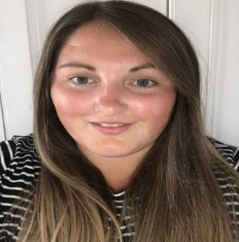
Thank you for your support in advance.
Please email kim.luter@sthelens.org.uk if you have any questions.
Kindest regards,
Miss Luter - FACES Manager

