Eccleston Lane Ends Primary School
Albany Avenue
Eccleston Park
Prescot
Merseyside
L34 2QN

Head teacher: Mrs C. Gowan
Telephone: 01744 678270
Fax: 01744 678272
http://www.ecclestonlaneends.st-helens.sch.uk/
E mail: Laneends@sthelens.org.uk

ELE ‘Teams’ Guide
IMPORTANT: Please download for home learning.
As you are already aware, there are restrictions placed on schools due to the Covid 19 outbreak. Even though these restrictions have changed the way our school works on a day-to-day basis, we would still like to ensure that important aspects of school life remain intact. It is extremely important that our pupils still have opportunities to be taught by their teacher. Teachers will use the Microsoft Teams video call feature to deliver some lessons.

Eccleston Lane Ends will be using an online forum developed by Microsoft and GDPR compliant called Microsoft Teams to deliver the ‘live lessons’. The Microsoft Teams software is similar to ‘zoom’ but it is filtered through St. Helens Council.
To access Microsoft teams, children’s usernames will take the format of…. ELE-year of entry-initials and no.1 for example John Smith who attends ELE’s Year 6 class would have the username ELE-14-js1@sthelens.org.uk
Some children who have the same initials as another child in their class will end their username with 2. If you are having difficulty loggin in, please contact Mr Loftus

Class | Year of Entry
Reception | 20
Year 1 | 19
Year 2 | 18
Year 3 | 17
Year 4 | 16
Year 5 | 15
Year 6 | 14

Children’s passwords have been set to their date of birth so that they are memorable and unique. For example a child born on 27th February 2010 will have the password 27-Feb-10. The first time you sign into TEAMS your child will be asked to change their password so it is personal. In order to do this you can access the St. Helens self-service portal. You will be asked to enter a phone number or email address (Parents) - a verification code can be sent to reset the password. We suggest the password you create should be 6 or more characters containing upper, lower case letters and numbers for security purposes.
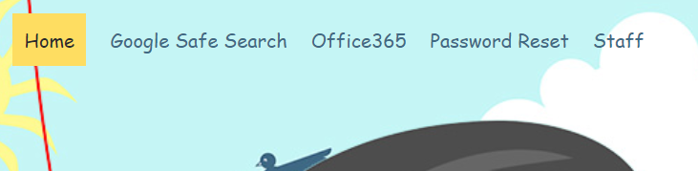
Microsoft teams can be found by clicking on the link https://www.sthelens.org.uk and clicking on ‘Office 365’ in the top right corner.

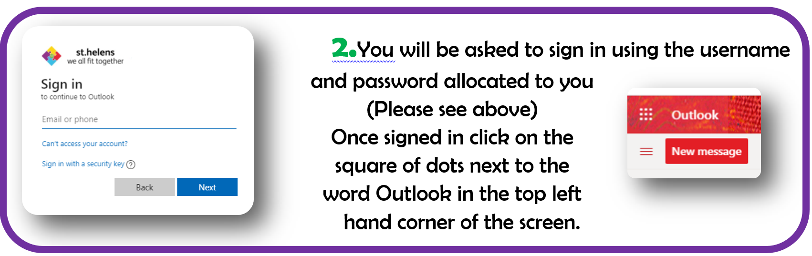
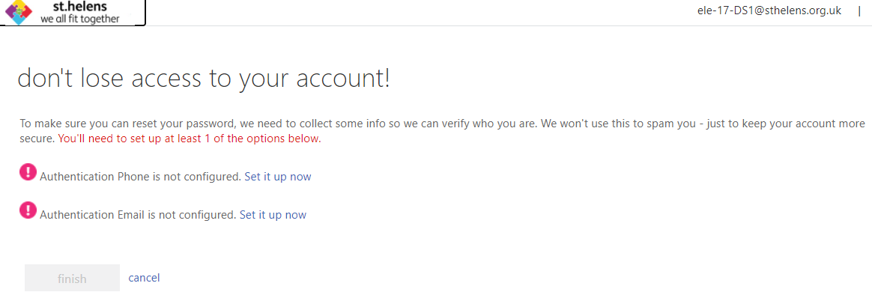

Follow the instructions and verify the account.
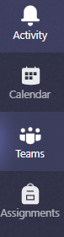
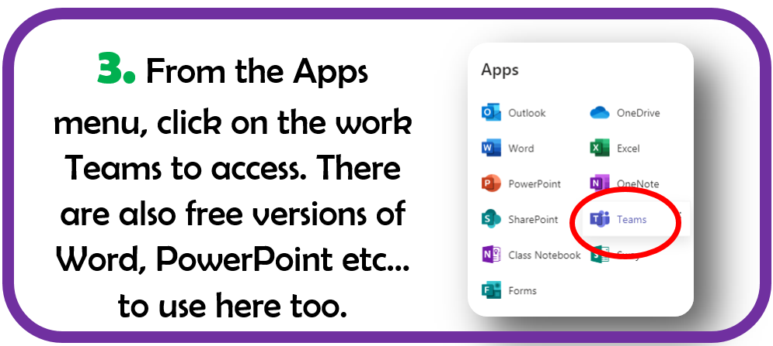
When in the calendar, you will be able to see events that you have been invited to such as English Lessons. On the day there will be a ‘join’ button to press.
4. From the menu on the left hand side of the screen select the ‘Calendar’ option.

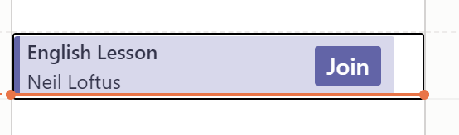

Please try to login to this software as soon as possible. If you have any difficulty in setting it up, please contact Mr Loftus on neil.loftus@sthelens.org.uk

Remember
Your child needs this to receive online lessons from their class teacher in the event of their whole class having to self-isolate.
Many thanks for your support
The E.L.E. Team

