Eccleston Lane Ends - Pupil premium strategy statement

This statement details our school’s use of pupil premium (and recovery premium for the 2022 to 2023 academic year) funding to help improve the attainment of our disadvantaged pupils.

It outlines our pupil premium strategy, how we intend to spend the funding in this academic year and the effect that last year’s spending of pupil premium had within our school.

School overview
Detail | Data
School name | Eccleston Lane Ends Primary School
Number of pupils in school | 246
Proportion (%) of pupil premium eligible pupils | 9% (2020-21)  10% (2021-22)
Academic year/years that our current pupil premium strategy plan covers (3 year plans are recommended) | 2022-2025
Date this statement was published | September 2022
Date on which it will be reviewed | July 2021
Statement authorised by | Sarah Bond
Pupil premium lead | Sarah Bond/Clare Grant
Governor / Trustee lead | Tracy Leather
Funding overview
Detail | Amount
Pupil premium funding allocation this academic year (£1385.00 per pupil FSM £2410.00 LAC/PLAC) LA take £410 per pupil LAC/PLAC) | £41,760
Recovery premium funding allocation this academic year  (£145.00) | £4,060
Pupil premium funding carried forward from previous years (enter £0 if not applicable) | £0
Total budget for this academic year | £45,820 (LA top slice some of this funding before it reaches our budget)

Part A: Pupil premium strategy plan

Statement of intent
Pupils at Eccleston Lane Ends Primary School will make expected progress in reading, writing and maths, through quality first teaching and increased opportunities for reinforcement of learning at home. We aim for disadvantaged pupils to have access to a wide range of interventions in school to assist in removing any barriers to learning.
We will provide an intensive pastoral support service for pupils, identified by school as vulnerable or in need. We will aim for disadvantaged pupils to develop their language and communication skills and for them to become competent readers.
We will facilitate pupils accessing a wide range of enrichment experiences both in and out of school, which will positively impact on the children’s academic achievement and well-being.

Challenges

This details the key challenges to achievement that we have identified among our disadvantaged pupils.
Challenge number | Detail of challenge
1 | Many of our pupil premium children also fit into another vulnerable group such as having an additional special educational need.
2 | May of our pupil premium children have poor oral language and communication skills.
3 | Some of the families of our pupil premium children are not as engaged in their children’s learning as those who are not pupil premium.
4 | Many of our pupil premium children do not have the same rich and varied experiences as non-pupil premium children impacting on their academic achievement.
5 | Many of our pupil premium children need to continue to access additional well-being opportunities to support social, emotional and mental health needs.

Intended outcomes
This explains the outcomes we are aiming for by the end of our current strategy plan, and how we will measure whether they have been achieved.
Intended outcome | Success criteria
Pupils make at least expected progress in reading, writing and maths (particular focus on Maths for 2022-23) | - Gaps will close in progress made between PP and non PP.
Pupils access a wide range of interventions to meet their SEND needs, including speech and language. | - As their SEND needs are being addressed, PP pupils make expected progress or exceed their targets set in RWM.
Pupils attendance is as high as non-pupil premium pupils. | - PP pupils attendance is at least 92%. PA for PP pupils is at least below local and national averages.
Pupils access a wide range of enrichment experiences both in and out of school. | - A wide range of extra-curricular activities will be offered to tap into our children’s passions.  - Discounts in line with our charging policy will continue to apply to pupil premium families for all enrichment opportunities to include trips and visits, music lessons and residentials etc.
Pupils social and emotional skills are not a barrier and allow them to engage fully with their learning. | - Pupils who have been identified as being vulnerable or in need will access individual pastoral support.  - Pupil surveys reflect enjoyment in school and improved attitudes to learning.  - Social skills, independence, perseverance and teamwork are developed.

Activity in this academic year
This details how we intend to spend our pupil premium (and recovery premium funding) this academic year to address the challenges listed above.

Teaching (for example, CPD, recruitment and retention)
Budgeted cost: £ 16,000
Activity | Evidence that supports this approach | Challenge number(s) addressed
FIRST CLASS teaching  - Quality first teaching for all pupils.  - TA CPD is ongoing for Maths and English by leads.  - Maths and English are high priority on school development plan.  - Pupil progress meetings track progress of PP pupils and appropriate, timely interventions are put in place. | - EEF Guide to Pupil Premium – maintains that a tiered approach is the most successful where teaching is the top priority, including CPD.  - Sutton Trust – quality first teaching has a direct impact on student outcomes.  - Training and supporting highly qualified teachers delivers targeted support. | 1, 2
- Use 5-a-day approach to ensure high quality daily teaching that all children can access.  - Diagnostic assessment used to address learning gaps | - EEF – Moving Forwards, Making a Difference  - Strategies such as Retrieval (Step 2 Cognitive and Metacognitive Strategies) and Entry and Exit tasks to be used by teachers to reflect on pupils’ thinking, strengths and weaknesses. | 1, 2
- Pastoral Leader is non-class based and able to deliver a range of social and emotional support programmes and ‘friendship’ interventions. | - EEF – Social and emotional learning – improves interaction with other and self-management of emotions – impacts on attitudes to learning and social relationships in school, which increases progress in attainment. | 5
Language Interventions  - Talk Boost  - Elklan  - NELI  - Chatty Therapy Toolkit  - Staff trained to use these, delivered on a structured rota | - Speech and language are one of the main barriers to pupils progressing in reading, writing, maths and the wider curriculum. | 1,2
Apps for home use  - The purchasing of Apps to support children’s learning at home eg. Teach Your Monster To Read, Letterjoin, Spelling Shed etc | - EEF – digital technology – clear evidence that technology approaches are beneficial for writing and maths practice. | 3

Targeted academic support (for example, tutoring, one-to-one support structured interventions)
Budgeted cost: £ 10,000
Activity | Evidence that supports this approach | Challenge number(s) addressed
- Learning Support Service to work with SEND children | - High quality, small group or individualised support from a specialist teacher to support children with a particular SEND need. | 1
- 1st Class@Number Training for 2 x teachers and 1 x TA. | - Small group intervention shown to be effective, the earlier the better.  - Focused at KS1 children – intervening early makes significant interventions. | 1
- 1:3 Maths Tuition | - Pupil premium children to be first selected for 1:3 small group tuition by class teacher.  - Question level analysis to focus the content of the sessions.  - EEF – Small group tuition is most likely to be effective if targeted at pupils’ specific needs. Diagnostic assessment can be used to assess the best way to target support. | 1

Wider strategies (for example, related to attendance, behaviour, wellbeing)
Budgeted cost: £ 15,000
Activity | Evidence that supports this approach | Challenge number(s) addressed
The Letterbox Club Reading Parcels | - Disadvantaged pupils nationally have a vocabulary that is much smaller than non-disadvantaged. This is especially true of those children in families in receipt of welfare benefits.  - By making schematic connections through literacy the children’s vocabulary increases which in turn enables them to know more and access more difficult texts. | 1, 3, 4
Breakfast Club | - Access to school breakfast club – helps to improve attendance and ensure that children have had a healthy and filling breakfast so they are able to access their learning. | 5
DESTY | - EEF – Social and emotional learning – improves interaction with other and self-management of emotions – impacts on attitudes to learning and social relationships in school, which increases progress in attainment. | 5
Subsidised Trips  - Reduction in cost of trips for PP  - Residential trip cost is greatly reduced for PP  - Cultural capital experiences promoted in the curriculum. | - Learning is contextualised in concrete experiences and language rich environments.  - Ofsted research (2019) places emphasis on improving cultural capital, especially for disadvantaged children.  - Pupil surveys reflect greater enjoyment and engagement in school.  - Enrichment activities offer children a context for learning and a stimulus to trigger their interest which can be evidenced in pupil books and data.  - EEF - outdoor adventure learning shows positive benefits on academic learning and self-confidence. | 4, 5

Total budgeted cost: £ 41,000

Part B: Review of outcomes in the previous academic year

Pupil premium strategy outcomes
This details the impact that our pupil premium activity had on pupils in the 2021 to 2022 academic year.
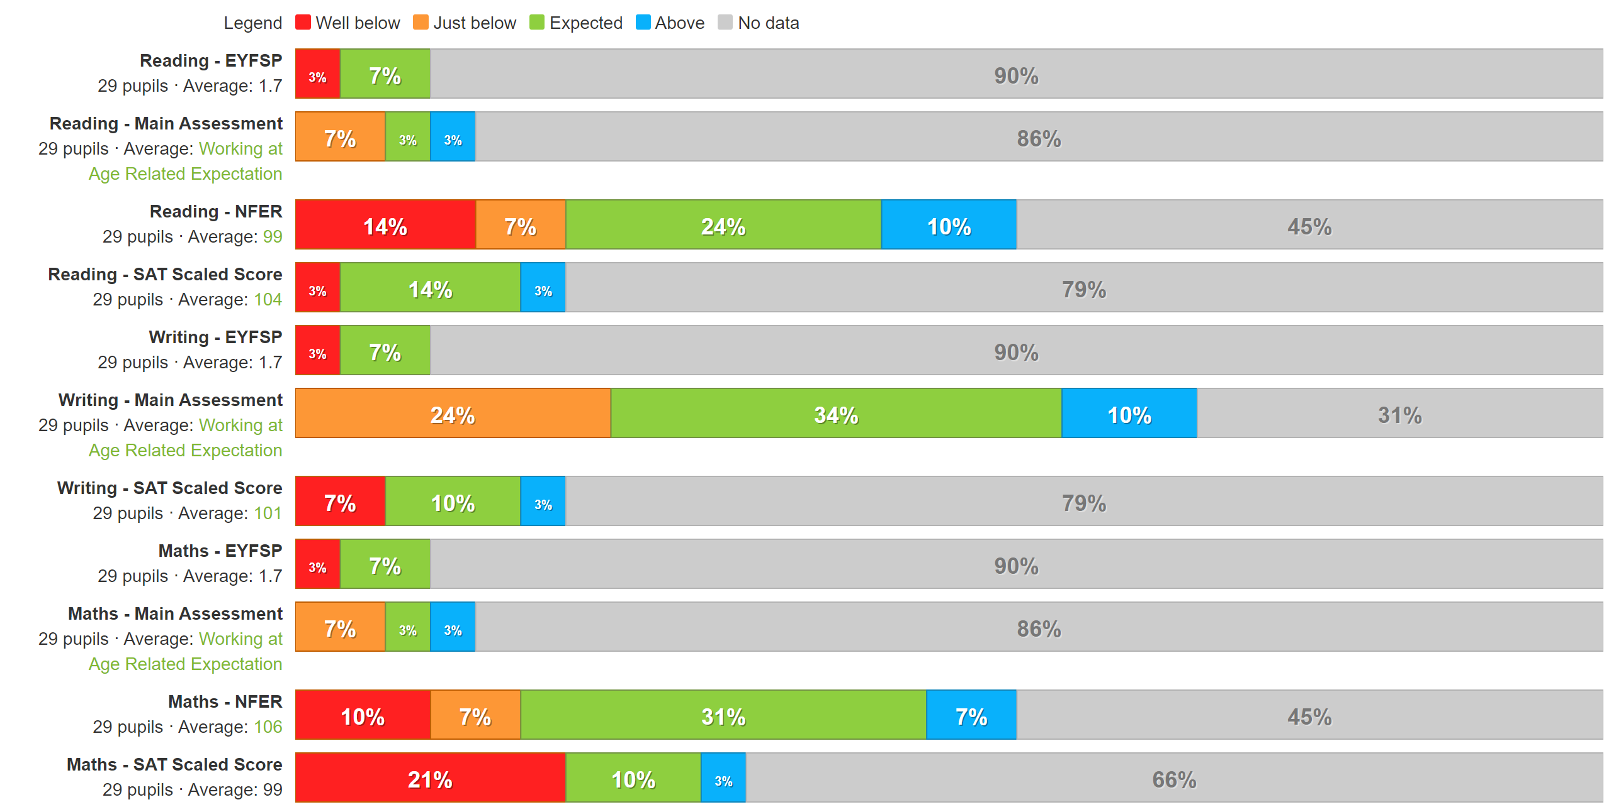
Reading
19/29 pupils (66%) achieved the expected level or better for their year group, across the school. 5/29 pupils (17%) of these are working at greater depth level for their year group. Of the 10 children who did not achieve the expected standard 4 of these are on SEND register.
Writing
19/29 pupils (66%) achieved the expected level or better for their year group across the school. 4/29 pupils (14%) of these are working at greater depth standard for their year group. Of the 10 children who did not achieve the expected standard 4 of these are on the SEND register.
Maths
17/29 pupils (59%) achieved the expected level or better for their year group across the school. 4/29 pupils (14%) of these are working at greater depth standard for their year group. Of the 12 pupils who did not achieve the expected standard 4 of these are on the SEND register.
Maths attainment for PP needs to be focus of future pupil progress meetings.
Outcome A – Pupils make at least expected progress in reading, writing and maths.
Reading progress Key Stage 2 – 3 out 6 PP children in Y6 made expected or better progress. Average progress measure was -1.65.
Writing progress Key Stage 2 – 4 out of 6 PP children in Y6 made expected or better progress in Writing. Average progress measure was -1.97.
Maths progress Key Stage 2 – 3 out of 6 PP children in Y6 made expected or better progress in Maths. Average progress measure was – 2.116.
This needs to continue to be a target moving into 2022-23.
Outcome B – Pupils access a wide range of interventions to meet their SEND needs, including speech and language.
PP pupils are a focus for intervention programmes and are discussed as a priority during pupil progress meetings. The progress of children accessing intervention programs is closely monitored and recorded on Tapestry. In weekly briefings with the class teacher, learning assistants discuss and inform on progress and plan the next steps. These outcomes are also regularly shared and monitored by the SENDCo.
Outcome C – Pupils attendance is as high as non-pupil premium pupils.
Attendance for pupils in 2021-22 in receipt of PP was 95.4% this was slightly higher than the pupils who were not in receipt of PP who had a figure for 2021-22 of 95%. The figure of 95.4% was also +4.9% above national attendance data for children in receipt of pupil premium. This continues to be of a high priority to ensure that children in receipt of pupil premium are in school as much as possible to maximise their learning potential. Where appropriate, breakfast clubs are funded to ensure that pupils are in school on time and ready to start the day.
Outcome D – Pupils access a wide range of enrichment experiences both in and out of school.
Pupil premium funding has allowed our PP children to access a range of extra-curricular provision including ukulele lessons, school trips, visits and residentials meaning that they have access to the same opportunities as other pupils.
Outcome E – Pupils social and emotional skills are not a barrier and allow them to engage fully with their learning.
DESTY continues to have a really positive impact upon our PP children, meaning fewer behavioural incidences and friendship issues amongst our PP children. There is an open door policy for pastoral support meaning that any child can access support at any time. 30% of children (7/25) identified as PP accessed pastoral support in the form of DESTY or emotional resilience support.
Families of some of our PP children have also accessed pastoral support and been directed to external agencies etc.

Externally provided programmes
Please include the names of any non-DfE programmes that you purchased in the previous academic year. This will help the Department for Education identify which ones are popular in England
Programme | Provider
DESTY | Education Desty
1st Class Number | Every Child Counts/Edge Hill
Talkboost | I Can
Elklan | Nuffield Early Language Intervention
NELI | Nuffield Early Language Intervention
Chatty Words Software | Chatty Therapy

Service pupil premium funding (optional)
For schools that receive this funding, you may wish to provide the following information:
Measure | Details
How did you spend your service pupil premium allocation last academic year? | £320 received for 1 pupil – pooled together with total PP funding allocation
What was the impact of that spending on service pupil premium eligible pupils? | Pupil achieved ARE in Reading, Writing and Maths (GD in Art – accessed additional art opportunities)

Further information (optional)
Use this space to provide any further information about your pupil premium strategy. For example, about your strategy planning, or other activity that you are implementing to support disadvantaged pupils, that is not dependent on pupil premium or recovery premium funding.

