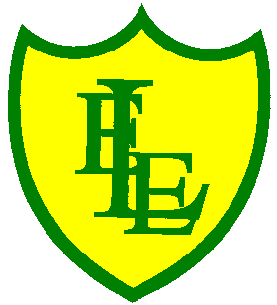
ECCLESTON LANE ENDS
SCHOOL CLOSURE WORK

YEAR: 3
DATE: 19th June 2020

Reading
Login to Purple Mash and read chapter 1 of ‘The Switcher’ and complete the quiz. I have also put some open ended questions and sequencing on the website.

Spellings

Practise your spellings for this week.
press | suppress | express | compress | impress
prevent | invent | venture | adventure | eventful

English Task
Complete the SPAG activity on the class website.

Login to Purple Mash. Pretend that you have a mysterious neighbour.

Describe this person and the peculiar things you have noticed about them.

Maths
Make sure that you spend some time on TT Rockstars today.

Complete today’s ‘Finding the ‘Turns and Angles’ worksheet I have put on the class page.

Keep playing on Prodigy Maths or Sumdog.

Spanish
Look of the class page for Spanish activities.

PHSE
Coasting the Earth
https://www.valuesmoneyandme.co.uk/teachers/costing-the-earth-ks1-ks2
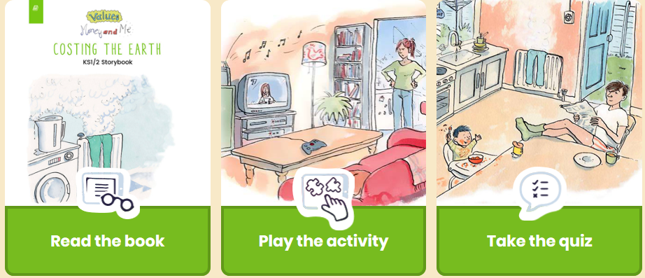
Children will explore how energy is used in the home and discover simple strategies to conserve energy. Children will plan individual actions to reduce energy waste around the home and the school environment. They will work collectively to create an energy-saving action plan for the class or the whole school.

Geography
Complete ‘Countries and Capitals’ worksheet.

