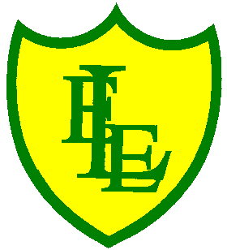
ECCLESTON LANE ENDS
SCHOOL CLOSURE WORK
YEAR: 2
DATE: Tuesday 23rd June 2020

PE: 9-9.30am
Log in to YouTube at 9am to access a 30-minute PE lesson with Joe Wicks, the body coach. https://www.youtube.com/user/thebodycoach1 Also, take a look at the keeping active and mindful website Fitter Future, for some different activities to stay active during this time.

Reading
Please continue with chapter two of the story, Poppa Joe’s Red Racer. Mia is very upset by the end of the day. She had forgotten her homework and heard the bad news about the new play area.
Once you have read the chapter please complete the activities set in the 2Do section.

Spellings
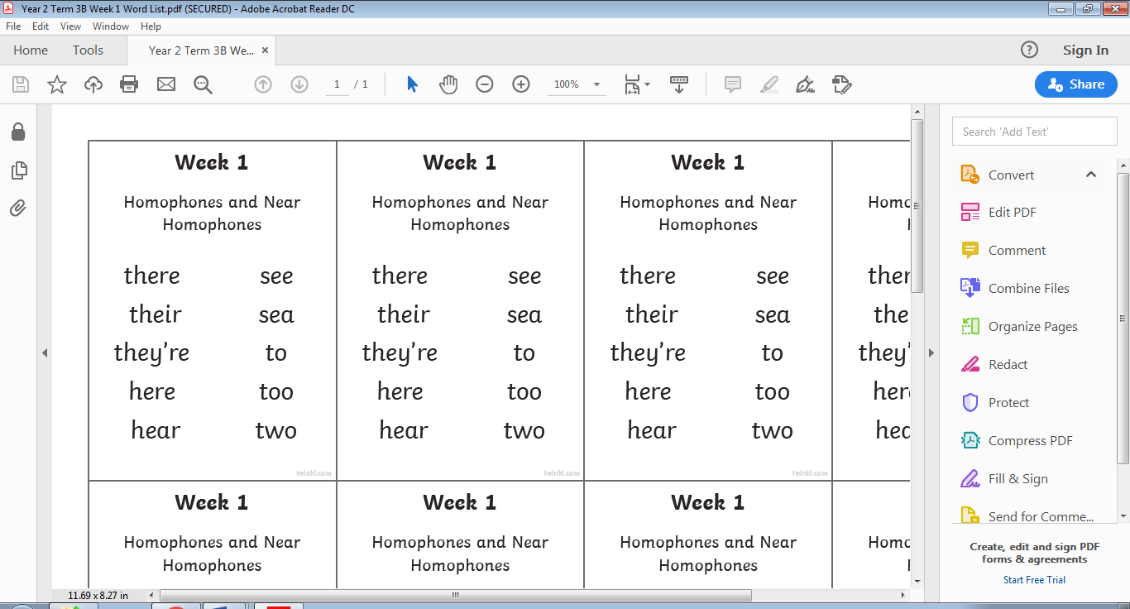
This week’s spellings are:

Please find an attached spelling activity for this week’s spellings in
home learning week 11.

English
In today’s English lesson, you are learning to identify and explain the meaning of this fable story. ‘The Bridge’ You should be able to about the morals (simply a message) within the story and write explanatory sentences in your home learning journal.
Parents: Discuss with the child the short video asking them about the events as they happened. Next, tell them that this kind of story is called a fable- the characters are usually depicted as animals and there is a moral to the story. What do they think that means? Thinking about ‘The Bridge’, what was the point of the film? Did it teach them anything? Explain the meaning of a moral, then ask the children to write what the moral of ‘The Bridge’
https://www.youtube.com/watch?v=_X_AfRk9F9

Maths
Today’s maths objective is to be able to describe 3-D shapes based on their properties, including the number of faces, vertices and edges.
Today’s activity is based on counting the number of faces, vertices (corners) and edges on different 3d shapes and then creating a table to organise the information.
face
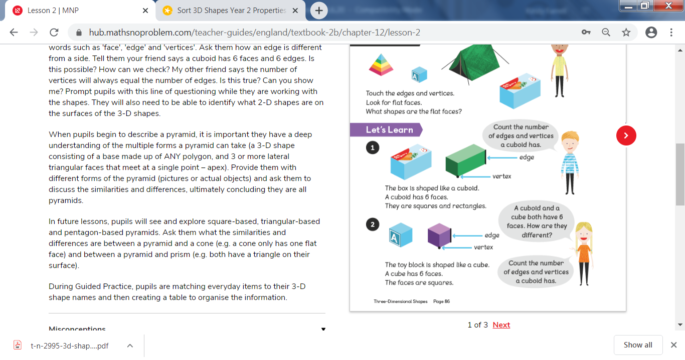
For reference:
edge

vertex

Extension- If you fancy a challenge, why not play ‘3D shape riddle code hunter’.
Children are to read the clues and work out the answers. If you are a QR reader on your tablet or smartphone there is an option for the children to scan the codes in to reveal the answers in the form of pictures or words.
*The game can be played without doing this*

Science
Please use the following link to access the BBC Bitesize Science game.
https://www.bbc.co.uk/games/embed/galaxy-pugs?exitGameUrl=https%3A%2F%2Fbbc.co.uk%2Fbitesize%2Farticles%2Fzn7bscw
Join the Pug Star!
The Galaxy Pugs are on a mission to explore planet Earth and they need your Science skills to succeed.
Help the pugs observe Earth’s animals, learn how to grow plants, study the human body, experiment with materials, explore our planet’s habitats and find tiny invertebrates hiding in a pond!
Collect mission badges and unlock shiny new upgrades to customise your pug ship.
Please complete the habitats game. Try to complete all 3 games for each section; Bronze, Silver and Gold. The more games you complete the more parts you will get to customise your ship!



