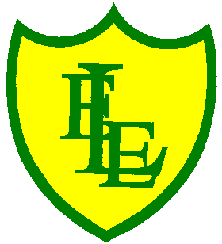
ECCLESTON LANE ENDS
SCHOOL CLOSURE WORK
YEAR: 2
DATE: Friday 19th June 2020

PE: 9-9.30am
Log in to YouTube at 9am to access a 30-minute PE lesson with Joe Wicks, the body coach. https://www.youtube.com/user/thebodycoach1 Also, take a look at the keeping active and mindful website Fitter Future, for some different activities to stay active during this time.

Reading
Today please read the final chapter of the story. In chapter 5, the family stop to help lots of people on their journey and the children write about their adventures in a blog. Dad gets a big surprise when he looks at his emails. How many people have been reading about Betty’s Blog? Please complete the activities once you have completed the story.

Spellings
I have uploaded a video for you to test your knowledge on this week’s spellings.
Get your Pencil and paper at the ready and GOOD LUCK!!

I have also uploaded some handwriting practise which includes all the spelling sentences from this week’s quiz.
Why not record on our spelling blog what you scored!!!

English
Today’s task will be to write the final paragraphs about the aftermath of the rescue until Grace’s death in 1842 and conclude your fact file. You need to write what happened after the rescue. What did she receive? Who from? How did Grace die? When date was this? Where is Grace memory preserved and honoured? Once you have completed your fact file go back and once again check your sentences. Edit your work, improve it. Put it with your front cover and take pride in the work you have created this week.

Maths
For today’s maths task, can you complete the attached year 2 maths mat. The maths mat has 8 sections and all sections focus on a different area of our curriculum. Please show your working out in your maths home learning book or on a separate sheet of paper. It is important to show your working out as to be able to explain your thinking is how you know you have understood the objective and that why you are deepening your thinking.

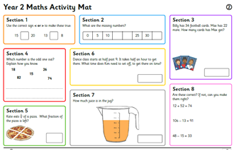

Extension- If you fancy a challenge, why not the Year 2 bbc Bitesize weekly maths challenges.

Art & Design
Lowry painted lots of people in his works but he didn’t make them very detailed.
Instead he drew them as ‘matchstick figures’, using simple shapes to show you what they were doing.
Today’s objective is to be able to draw figures in a Lowry’s matchstick style.
Follow the attached worksheets. Can you point out the matchstick figures in a painting by LS Lowry? Now think about what a particular figure is doing in a painting by LS Lowry. Now look at the attached sheet for matchstick figures examples. When beginning to draw your own figures,

- Use pencils, pens, pastels or charcoal to draw your matchstick figures. Make sure you try drawing with each of these.
- Think about what your people are doing. Use the shape of their bodies to show their actions.
- Fill your page with small matchstick people. They are going to fill up your Lowry City Collage!
