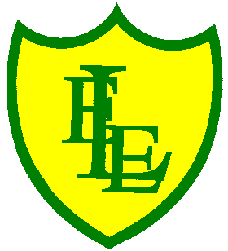
ECCLESTON LANE ENDS
SCHOOL CLOSURE WORK

YEAR: 3
DATE: 12th June 2020

Reading
Login to Purple Mash and read chapter 2 of ‘Wet Breaks’ and complete the quiz. I have also put some open ended questions and sequencing on the website.

Spellings

Practise your spellings for this week.
scope | telescope | microscope | horoscope | periscope
inspect | spectator | respect | perspective | spectacles

English Task
Complete the SPAG activity on the class website.

Login to Purple Mash. Create an annotated diagram to describe Mrs Cruikshank.

Maths
Make sure that you spend some time on TT Rockstars today.

Complete today’s ’24-hour clock’ worksheet I have put on the class page.

Keep playing on Prodigy Maths or Sumdog.

Science
There is a ‘Fun with density’ worksheet on our class page.

Geography
Write down the capital cities of the countries below. Don’t forget the capital letters!

