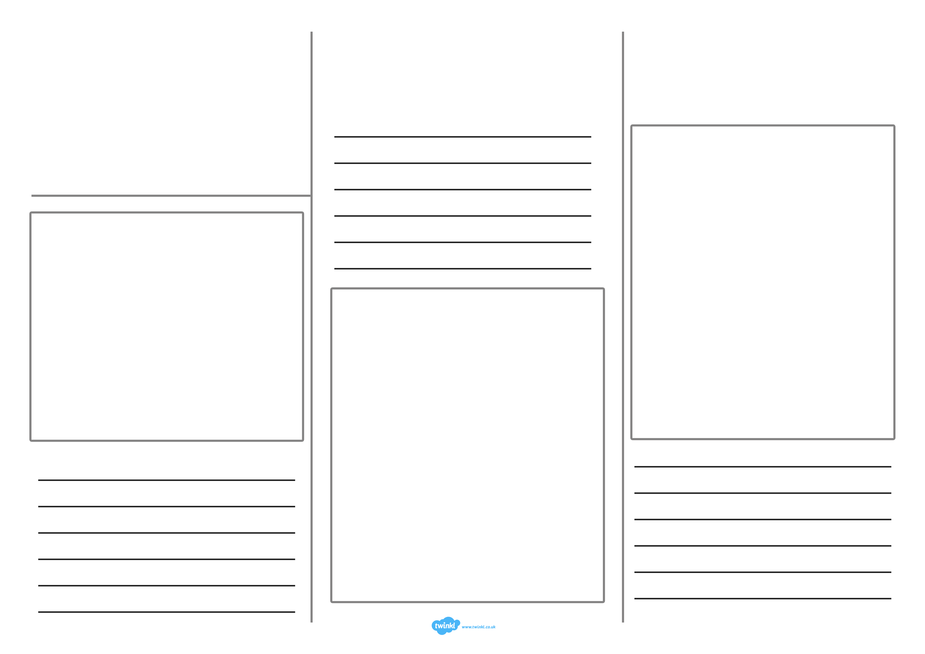
Come and visit
St.Ives
What can you do there?

Where is St.Ives?

Come and visit
St.Ives

Where can you eat and drink?

Where can you stay?

Insert text
Insert text
Insert text

