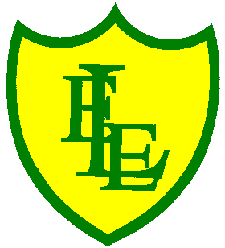
ECCLESTON LANE ENDS
SCHOOL CLOSURE WORK
YEAR: 2
DATE: Tuesday 16th June 2020

PE: 9-9.30am
Log in to YouTube at 9am to access a 30-minute PE lesson with Joe Wicks, the body coach. https://www.youtube.com/user/thebodycoach1 Also, take a look at the keeping active and mindful website Fitter Future, for some different activities to stay active during this time.

Reading
Please continue with chapter two of the story, Charlie and the campervan.
The van arrived looking old and worn. Charlie really wants it to be ready for her birthday in two weeks’ time. Will there be enough time and money to do it? Once you have read the chapter please complete the activities set in the 2Do section.

Spellings
This week’s spellings are:
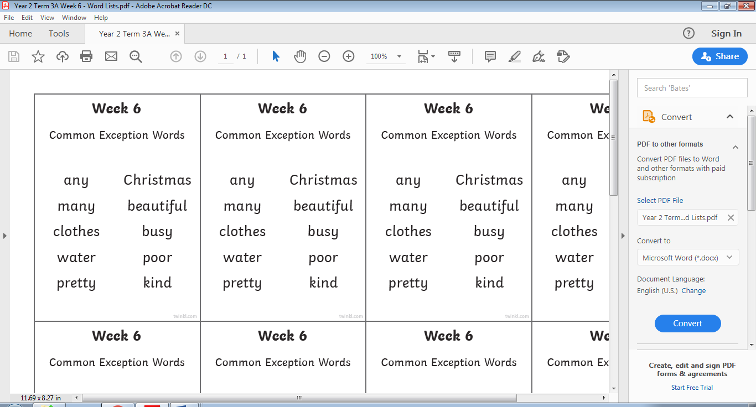

Please find an attached spelling activity for this week’s spellings in
home learning week 10.

English
Today in English, you will start to make a fact file on Grace Darling. You will have gathered lots of information last week on her, you have found details and facts about her and why she is an important individual. Using all this planning you will compile an information text. (We looked at information texts before in our cheetahs and lions topic). Watch the video below about her life again and design a front cover to go in front of the information text that you will start to create tomorrow. Your front cover has to show her name and pictures of Grace throughout her life. Use a plain piece of A4 paper to create this. Once designed, colour it in.
https://www.youtube.com/watch?v=Yv3eS40j0N0
Duration 11.49

Maths

Today’s maths objective is to be able to draw basic shapes on a grid.

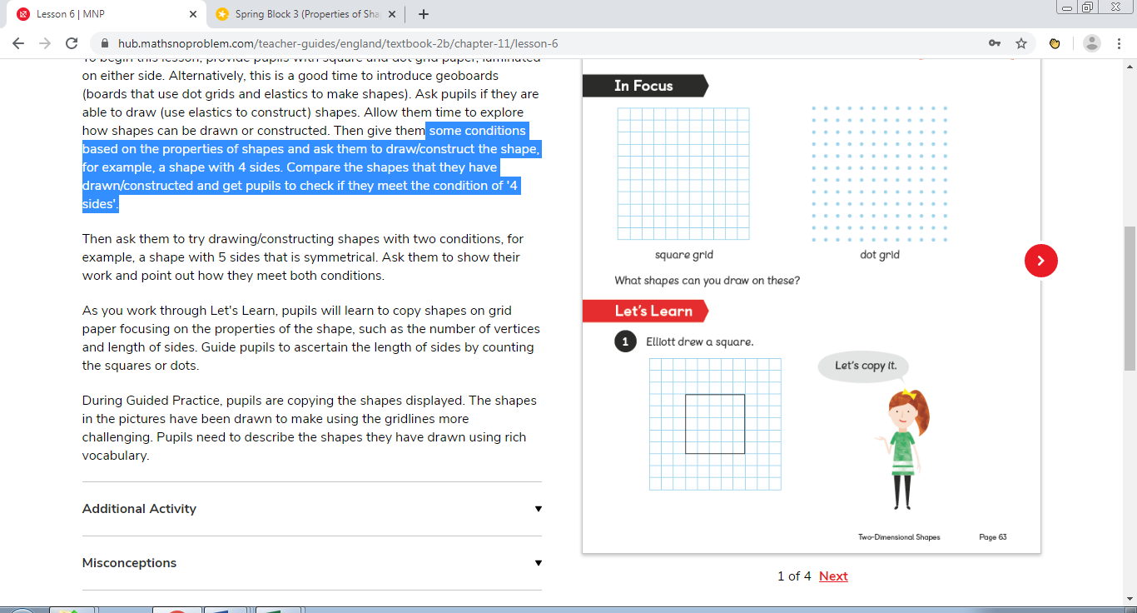
To be able to draw such shapes, the children will need to think about some conditions based on the properties of shapes. For example, a shape with 4 equal sides. Ask the children to count the number of squares that each side (the length of each side is 5 squares). The children can even plot the 4 corners on their squared paper before joining the sides up.

**Make sure your child counts the number of squares taken up by any side of a particular shape. Task sheet attached.

If you don’t have a printer, these shapes can be drawn in your home learning books or on squared paper.

Computing
Please use the following link and watch the video to learn about coding.
https://www.bbc.co.uk/bitesize/topics/z3tbwmn/articles/zykx6sg
When you learn to code you can make things happen on your computer. You can make anything you want with code. It could be a game, some pictures or a film. Computer code is a set of rules or instructions. It is made up of words and numbers and when you put them in the right order it will tell your computer what you want it to do. You can program lots of things with code.
Once you have watched the video play the game, ‘Does not compute’.

