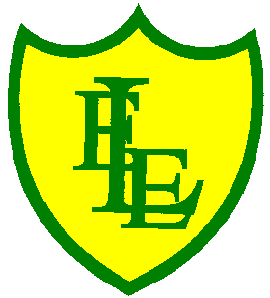
ECCLESTON LANE ENDS
SCHOOL CLOSURE WORK
YEAR: 2
DATE: Monday 15th June 2020

PE: 9-9.30am
Log in to YouTube at 9am to access a 30-minute PE lesson with Joe Wicks, the body coach. https://www.youtube.com/user/thebodycoach1 Also, take a look at the keeping active and mindful website Fitter Future, for some different activities to stay active during this time.
Please see our class page for details about a virtual PE competition. The School Games Local Organising Committee is challenging pupils to design a logo for the Virtual Merseyside School Games.

Reading
Please access purple mash to read chapter one of the story, Charlie and the Campervan.
Charlie and her little brother Dan are so excited. Their new camper van is about to arrive, and they can’t wait to see what colour it is going to be.
Once you have read chapter one, please complete the quiz and other activities based on what you have read, in the 2Do section.

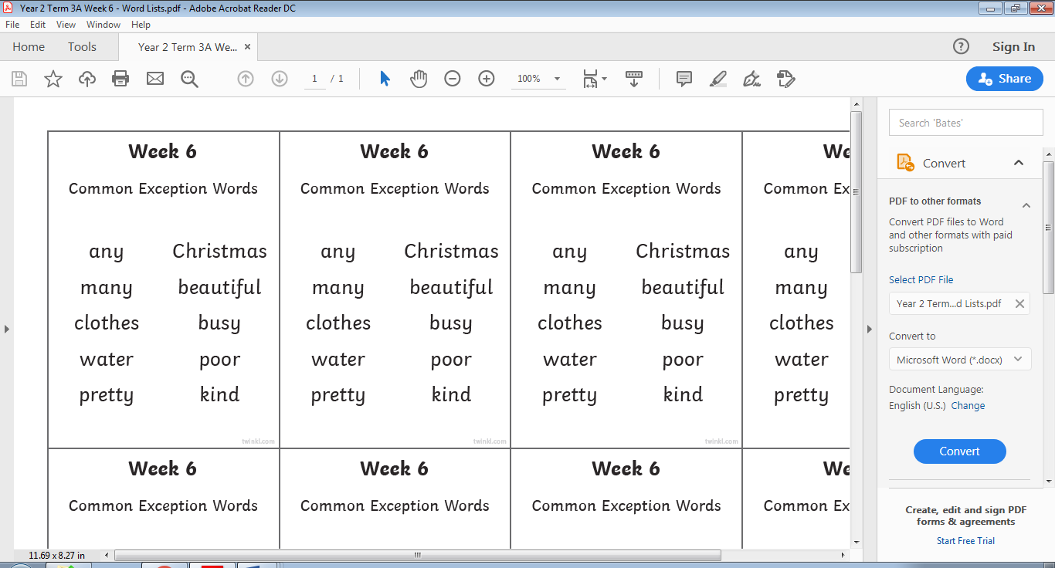
Spellings
This week’s spellings are:

Please find an attached spelling activity for this week’s spellings in our home learning week 10 folder on our class page.

English
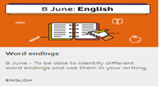
Today’s task is to build your knowledge of word endings and develop your vocabulary. This lesson includes a game to practise your knowledge of word endings three activities to do at home. Please complete all of the activities in your home learning journal. This lesson will help us this week when we start to write our information fact file about Grace Darling. https://www.bbc.co.uk/bitesize/articles/zxpx8hv

Maths
Today’s maths objective is to be able to describe the terms in a pattern.
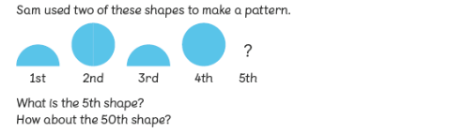
If your child can make circles of paper, ask them to begin creating the pattern.
How can they know what the 5th shape is?
Can they predict what the 10th shape is?
How do they know? Can they predict what the 50th shape is?
Can they come up with a rule to figure out what the 50th shape would be?
How is this possible?
- Prompt them to look at odd and even numbers in the pattern, for example, to look at the pattern in multiples of 5.

For today’s activity, the children will be looking at patterns and identifying what the next shape will be. These patterns vary in size, shape, colour and orientation.

Science
Please use the following link to access the BBC Bitesize activity ‘What is a food chain?’ Watch the video to learn about different food chains.
https://www.bbc.co.uk/bitesize/topics/zx882hv/articles/z3c2xnb
Once you’ve watched the video take the, what is a food chain? quiz to test your knowledge of food chains.

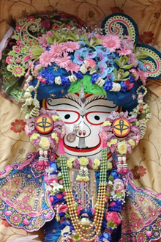
RE
On 23rd June Hindus will celebrate the festival Rath Yatra.
Look at the pictures and decide what you think the festival is about. Work through the PowerPoint to learn more about the Rath Yatra festival.
