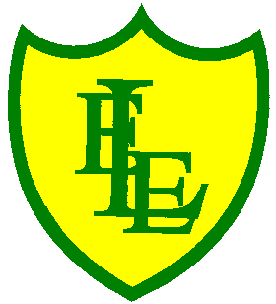
ECCLESTON LANE ENDS
SCHOOL CLOSURE WORK

YEAR: 3
DATE: 11th June 2020

Reading
Login to Purple Mash and read chapter 1 of ‘Wet Breaks’ and complete the quiz. I have also put some open ended questions and sequencing on the website.

Spellings

Practise your spellings for this week.
scope | telescope | microscope | horoscope | periscope
inspect | spectator | respect | perspective | spectacles

English Task
Complete the SPAG activity on the class website.

Login to Purple Mash. Mrs Cruikshank's classroom is rather unusual because of her trophy cabinets. Use this template to describe your classroom. I know it’s been a long time, but try to remember.

Maths
Make sure that you spend some time on TT Rockstars today.

Complete today’s ‘Using am and pm’ worksheet I have put on the class page.

Keep playing on Prodigy Maths or Sumdog.

PHSE

Focus your mind and complete the indoor scavenger hunt.

