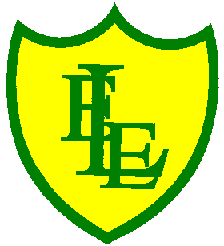
ECCLESTON LANE ENDS
SCHOOL CLOSURE WORK

YEAR: 3
DATE: 9th June 2020

Reading
Login to Purple Mash and read chapter 4 of ‘Replica Face’ and complete the quiz. I have also put some open ended questions and sequencing on the website.

Spellings

Practise your spellings for this week.
scope | telescope | microscope | horoscope | periscope
inspect | spectator | respect | perspective | spectacles

English Task
Complete the SPAG activity on the class website.

Purple Mash
Mr Bradby dealt with parents who complained about the chaotic day. Imagine that you are one of the disgruntled parents. Write a letter of complaint to Mr Bradby.

Avatar Persona
How does you avatar change how you are seen by others?

Developing Tray
Can you remove the 'masks' from these letters to reveal the hidden passage?

Maths
Make sure that you spend some time on TT Rockstars today.

Complete today’s ‘Telling the time to 5 mins’ worksheet I have put on the class page.

Keep playing on Prodigy Maths or Sumdog.

P.E.
You will find a ‘Home Pentathlon’ in the news items on our home page. Have a go and tweet your child completing the activities.

