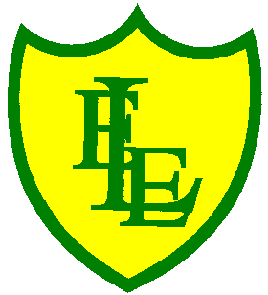
ECCLESTON LANE ENDS
SCHOOL CLOSURE WORK

YEAR: 3
DATE: 10th June 2020

Reading
Login to Purple Mash and read chapter 5 of ‘Replica Face’ and complete the quiz. I have also put some open ended questions and sequencing on the website.

Spellings

Practise your spellings for this week.
scope | telescope | microscope | horoscope | periscope
inspect | spectator | respect | perspective | spectacles

English Task
Complete the SPAG activity on the class website.

Login to Purple Mash. Now that you have finished reading Replica Face, write a review about the story.

Maths
Make sure that you spend some time on TT Rockstars today.

Complete today’s ‘Telling the time to the minute’ worksheet I have put on the class page.

Keep playing on Prodigy Maths or Sumdog.

Computing
Login to Purple Mash
Edit the example to make your own branching database. Who could someone be if they put on a mystical mask?

PHSE
Complete ‘My Behaviour Masks’ on Purple Mash.

