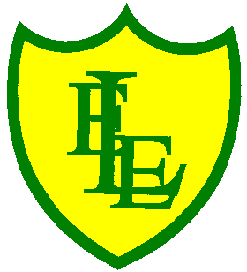
ECCLESTON LANE ENDS
SCHOOL CLOSURE WORK

YEAR: 3
DATE: 8th June 2020

Reading
Login to Purple Mash and read chapter 3 of ‘Replica Face’ and complete the quiz. I have also put some open ended questions and sequencing on the website.

Spellings

Practise your spellings for this week.
scope | telescope | microscope | horoscope | periscope
inspect | spectator | respect | perspective | spectacles

English Task
Complete the SPAG activity on the class website.

Login to Purple Mash. Safia has sent you an email. Write to her about your ideas.

Maths
Make sure that you spend some time on TT Rockstars today.

Complete today’s ‘Hours in a day’ worksheet I have put on the class page.

Keep playing on Prodigy Maths or Sumdog.

Computing
Login to Purple Mash and create animated scenes by repeating and changing images in a storyboard.

Music
Login to Purple Mash and listen to the example and try to compose your own morphing music. Use this to accompany your animation.

Drag and drop sounds into the grid: explore harmony and build up musical scores.

Spanish
Look of the class page for Spanish activities.

