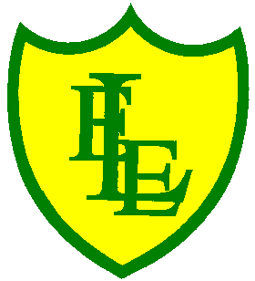
ECCLESTON LANE ENDS
SCHOOL CLOSURE WORK

YEAR: 2
DATE: Thursday 11th June 2020

PE: 9-9.30am
Log in to YouTube at 9am to access a 30-minute PE lesson with Joe Wicks, the body coach. https://www.youtube.com/user/thebodycoach1 Also, take a look at the keeping active and mindful website Fitter Future, for some different activities to stay active during this time.

Reading
Today in Chapter 4, the children meet Captain Chips and find out all about the real stories of the Pirates of Puddleton Bay. The pirates are here to help them! After you have read chapter 4, please complete the activities based on this chapter.

Spellings
This week’s spellings are:

Please find an attached spelling activity for this week’s spellings in
home learning week 9.

English
Today’s English task is to write sentences to describe the pictures that show the story of Grace Darling and the dramatic rescue that she was involved in. Please complete this work in your home learning journal. Parents please find enclosed a worksheet and instructions for what to do. There is also an example sentence. You will need scissors and glue/sellotape for this task if available.

Maths
Today’s maths objective is to be able to sort 2-D shapes based on their properties.
As a starter activity, ask your child to look at the shapes below. Ask them to talk about the properties of the shapes and whether they can see any similarities among them. Can they put any of the shapes into groups such as shapes with 3 sides and shapes with 4 sides. It is important that pupils discover different ways to sort the shapes without being told directly. Think of as many different groups as you can.

Activity attached –Sorting shapes

Extension- If you fancy a challenge, why have a go at the 2D sorting challenges (attached).

Spanish
I would like you to continue to learn Spanish colours. Click on the link below to listen to a colour song. There are lots of Spanish words so listen carefully for those colour words.

https://www.youtube.com/watch?v=DsRKoZGaoEM
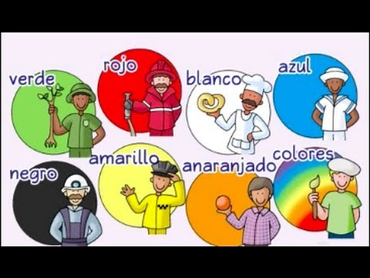 | Spanish for Kids | Colors, colors - ¡Colores, colores! - Calico Spanish Learning Songs for Kids  Want AD-FREE music and story-based curriculum? CalicoSpanish.com. https://CalicoSpanish.com - Start your FREE lessons today! Spanish for kids is always fun when you teach with Calico! Check out our Stories program to access hundreds of lessons, activities, games, and videos. Calico Stories is the most comprehensive, affordable way to learn ...  www.youtube.com

Next I would like you to draw a picture and have a go at labelling the colours you use. Your picture could be of a flower from your garden or maybe your favourite vehicle/car. This is your choice so make sure it is something you really like to draw and try to use at least three different colours. Try to have a go at spelling the Spanish word correctly. Use the colour cars poster to help you. Well done children - I know this can be tricky. Once you have finished your picture I would like you to teach the Spanish colour words you used to someone else in your house. This could be another member of your family or even your pet or favourite teddy bear!

R.E
This week is about sharing.
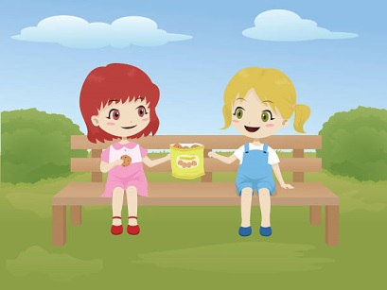
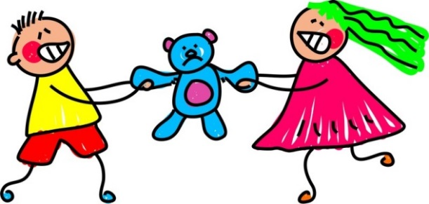

What do you notice about these two pictures?

Watch this film where Charlie and her friend Blue go to visit the Gurdwara, the Sikh place of worship.

https://www.truetube.co.uk/film/charlie-and-blue-go-gurdwara

Can you spot the different ways people share while at the Gurdwara?

