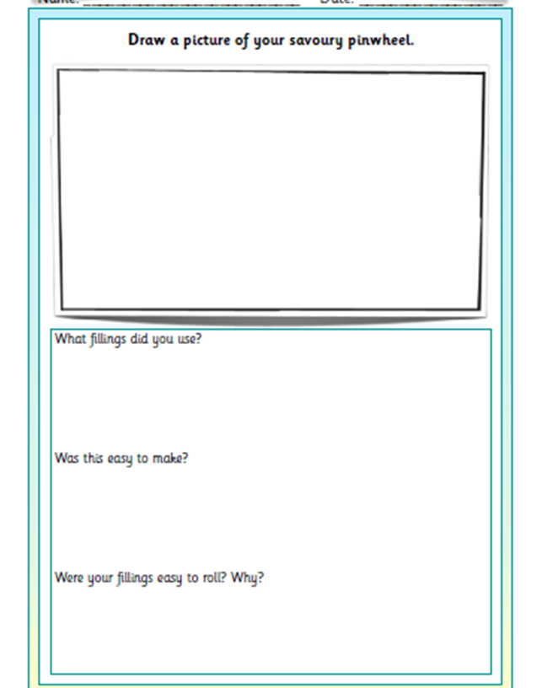

What equipment will you need?

What filling will you use?

How will you make it? 

Draw a picture of your edible boat