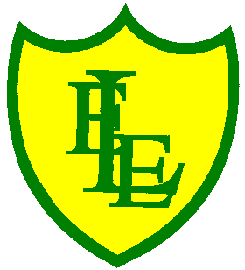
ECCLESTON LANE ENDS
SCHOOL CLOSURE WORK
YEAR: 2
DATE: Friday 12th June 2020

PE: 9-9.30am
Log in to YouTube at 9am to access a 30-minute PE lesson with Joe Wicks, the body coach. https://www.youtube.com/user/thebodycoach1 Also, take a look at the keeping active and mindful website Fitter Future, for some different activities to stay active during this time.

Reading
Today please read the final chapter of the story. In chapter 5, Puddleton Bay gets back to normal thanks to all the help from the pirates. Dad gets a new café and all the visitors come back to the bay. Please complete the activities once you have completed the story.

Spellings
I have uploaded a video for you to test your knowledge on this week’s spellings.
Get your Pencil and paper at the ready and GOOD LUCK!!

I have also uploaded some handwriting practise which includes all the spelling sentences from this week’s quiz.
Why not record on our spelling blog what you scored!!!

English/DT
Today’s task will be to design a poster that Grace Darling may have received as a thank you for all of her hard work rescuing the survivors. Remember she also got a £50 reward. You must include the following on your poster; Grace, her father, the sea, the rescue boat they travelled in and her reward. You can use bright colours, felts tip pens, crayons or paints to design your poster.

Maths
Today’s maths objective is to be able to identify the missing shape in patterns using shapes of different colours, orientations and sizes.
Look at this pattern made with 2D shapes.
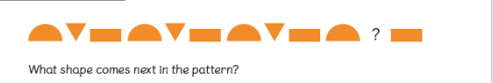
Can you identify the next shape in the pattern? How do they know? Can you see where the pattern starts to repeat itself?
For today’s activity, to begin with, challenges include questions to support recognising and continuing patterns using two different 2D shapes, all with the same orientation.
Then to extend your learning on page 2, questions include recognising and continuing patterns using up to three different 2D shapes, some patterns including the same shape in different orientations.

Extension- If you fancy a challenge, why not try to solve this week’s Bitesize Year 2 Maths challenges.

Design Technology
This week we have another DT seaside focus. Your task today is to design and if possible create your own ‘edible boat’ (this can be done on another day if time and resources).
This is your chance to get really creative, as long as you stick to the brief in that your boat is
1. Edible (be able to eat it)
2. Based on a boat theme
I have attached some photo ideas for different ‘edible boats’ based on this theme.

Have fun and please email Mrs Farrell your creations! We can’t wait to see them!!!

. 