Thursday 11th June 2020
Why do we remember Grace Darling?
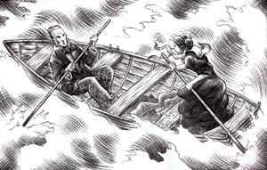 | 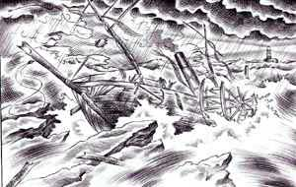 | 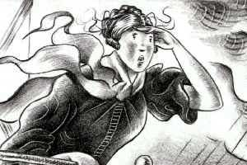 | 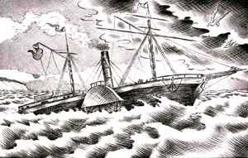 | 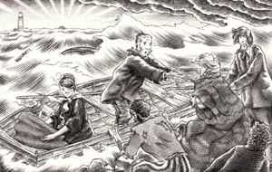

Cut out each of the pictures above and put them in the correct order to tell the story of why we remember Grace Darling. Then, write a short sentences in your home learning journey for each picture to tell the story in your own words.
You need to use different time openers. Use conjunctions, remember we recapped on these last week. Use capital letters for names of people. Try ti include apostrophes and expanded noun phrases.
An example sentence for the first picture. Can you improve mine? Grace and her father William rowed extremely hard on their perilous journey across the deep, dark sea to reach the people who needed rescuing. They knew they mustn’t give up even though they were wet, cold and tired.

