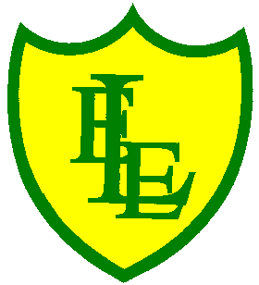
ECCLESTON LANE ENDS
SCHOOL CLOSURE WORK

YEAR: 2
DATE: Wednesday 10th June 2020

PE: 9-9.30am
Log in to YouTube at 9am to access a 30-minute PE lesson with Joe Wicks, the body coach. https://www.youtube.com/user/thebodycoach1 Also, take a look at the keeping active and mindful website Fitter Future, for some different activities to stay active during this time.

Reading
Carry on reading the story, Pirates of Puddleton Bay. Today in chapter three, lots of Max’s friends and family come to help. While they’re clearing up Max shares some old stories about the pirates of Puddleton Bay. Once you have read the chapter, please complete the activities set.

Spellings
This week’s spellings are:

Handwriting practise sheets for this week’s spellings are available to download on spelling section at the top of our class page.

English
One of today’s task is to edit yesterday’s work, go back over your diary entry and improve the punctuation and grammar. Improve your sentences turning them from good sentences to great sentences. You may have to change some of the adjectives, include an expanded noun phrase and add in adverbs? Your next task is to write another diary entry but this time when Grace was older and the entry must be from the evening of 7th September 1838 when Grace went out to sea to rescue people from the sea. Think about how she would be feeling, discuss the weather and describe the sounds and darkness of the night. Talk about your clothing, how your body reacted to the water. Remember to use the checklist below when you have. If you need to recap the information the power point is still on the website from yesterday.
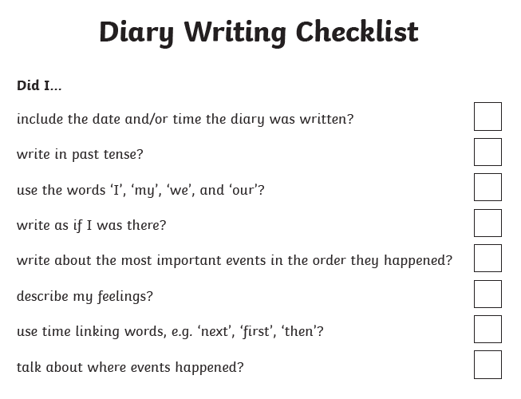

Maths
Today in Maths your task is to identify and describe the properties of 2-D shapes, including the number of sides and line symmetry in a vertical line.
There are three different levels starting at level 1 on page 1.
To begin with, challenges include questions to support identifying vertical lines of symmetry in 2D shapes. All shapes presented on dotted paper.
Then to extend your learning on page 2, questions include identifying vertical lines of symmetry in 2D shapes and moving onto identifying vertical and horizontal lines of symmetry in 2D shapes and images.

Challenge – If you fancy a challenge, why not have a go at working out and completing the Summer 1 maths mat (attached).

Geography
Lets explore a seaside…
Today your task is to explore what the seaside town of St. Ives is like, without leaving the house but by looking at information, videos and photographs.
Watch this digital postcard all about St.Ives Bay:
https://www.youtube.com/watch?v=dksyH4JmfKE
Use your Word Web Frame to make notes, draw pictures and record your observations about the town (see attached worksheet).
Things to think about – Where is St.Ives? What can you do there? Where can you stay? What places are there to eat and drink?

