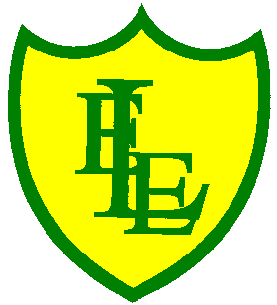
ECCLESTON LANE ENDS
SCHOOL CLOSURE WORK
YEAR: 2
DATE: Tuesday 9th June 2020

PE: 9-9.30am
Log in to YouTube at 9am to access a 30-minute PE lesson with Joe Wicks, the body coach. https://www.youtube.com/user/thebodycoach1 Also, take a look at the keeping active and mindful website Fitter Future, for some different activities to stay active during this time.

Reading
Please continue to read chapter 2 of Pirates of Puddleton Bay. The harbour is full of plastic bottles and Max’s Dads café has lost its roof. How are they going to clear up the harbour before the tide comes back in? Once you have read the chapter please complete the activities set in the 2Do section.

Spellings
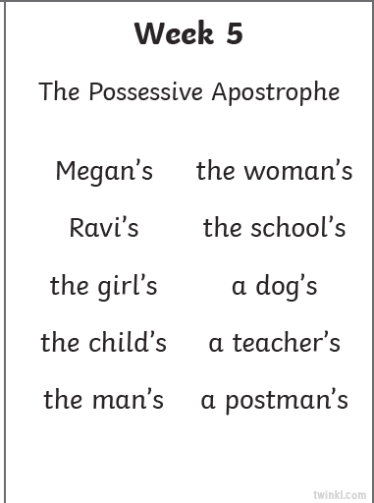
This week’s spellings are:

Please find an attached spelling activity for this week’s spellings in
home learning week 9.

English
Using the information that you gathered yesterday and reading the PowerPoint included, I would like you to write about how Grace Darling may have felt moving to the lighthouse at Brownsman Island in the Farne Islands. The family moved to this new lighthouse in 1825, when Grace was ten. It would have been very different to the houses we all live in now. Simple grocery shopping would have been difficult, and it may have been a lonely place times. I would like you to write a diary entry from Grace’s point of view describing life in the lighthouse in 1825. We have looked at the features of diary entries when we wrote about the great fire of London but I have included a diary writing checklist to remind you of key information to include. You will need to think about what tense you would be using for this writing. Think about Grace’s feelings, what her daily life might have been like and you need to include a date (it can be a made up one from 1825). Remember she is surrounded by the sea, include this in your writing. I would like you to also concentrate on using your cursive handwriting and forming all the letters correctly thinking about the sizing and joining of the letters when writing your diary entry.
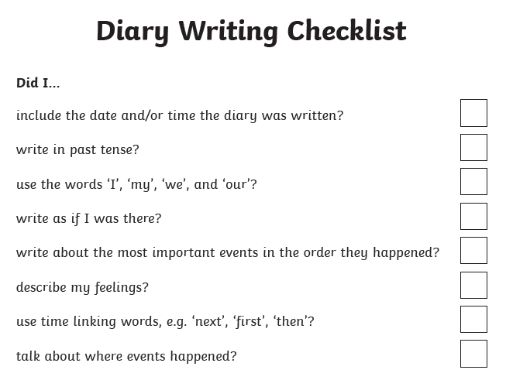

Maths
Today’s objective is to be able to identify lines of symmetry in 2-D shapes.
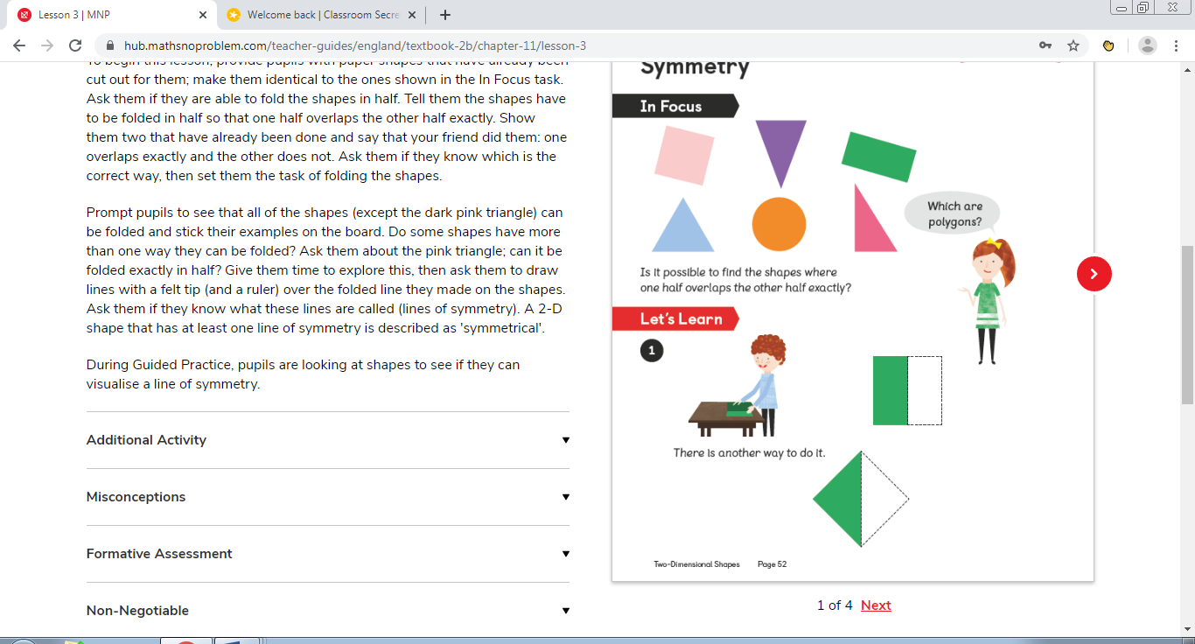
Parents - If you can, provide your child with an equal square of paper (a post it note it great). Then ask your child if they are able to fold the shapes in half. Tell them the shapes have to be folded in half so that one-half overlaps the other half exactly. Show them by unfolding their square.
Looking at the shapes above, all of the shapes (except the dark pink triangle) can be folded into two equal halves. Do some shapes have more than one way they can be folded? Ask them about the pink triangle; can it be folded exactly in half?
Ask them to draw lines with a felt tip (and a ruler) over the folded line they made on the shapes. Ask them if they know what these lines are called (lines of symmetry). A 2-D shape that has at least one line of symmetry is described as 'symmetrical'. The pink triangle does not have any lines of symmetry and cannot be folded equally.
Activity included – Identifying lines of symmetry

Computing
Once you have read chapter 2 of the story, Pirates of Puddleton Bay, please send an email back to Max. Please find the 2Email activity in the 2Do section on purple mash. Max needs your help an has sent you all the following email:
Hi everyone,
I really need your help. You will have read all about the problems we are having in Puddleton Bay with all the plastic bottles. I wonder if you have any good ideas for collecting the bottles very quickly? You may know some good websites where I can find things out too. Please can you send me any ideas to get the job done as fast as we can?
Thank you
from
Max
You could even draw a picture to describe some of your ideas and attach it to your email when you send your reply back to Max.

