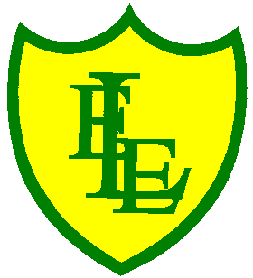
ECCLESTON LANE ENDS
SCHOOL CLOSURE WORK
YEAR: 2
DATE: Monday 8th June 2020

PE: 9-9.30am
Log in to YouTube at 9am to access a 30-minute PE lesson with Joe Wicks, the body coach. https://www.youtube.com/user/thebodycoach1 Also, take a look at the keeping active and mindful website Fitter Future, for some different activities to stay active during this time.

Reading
Please access purple mash to read chapter one of the story, Pirates of Puddleton Bay. There is a storm in Puddleton Bay and Max can’t wait to get down to the harbour to find out what has happened. Once you have read chapter one, please complete the quiz and other activities based on what you have read, in the 2Do section.

Spellings
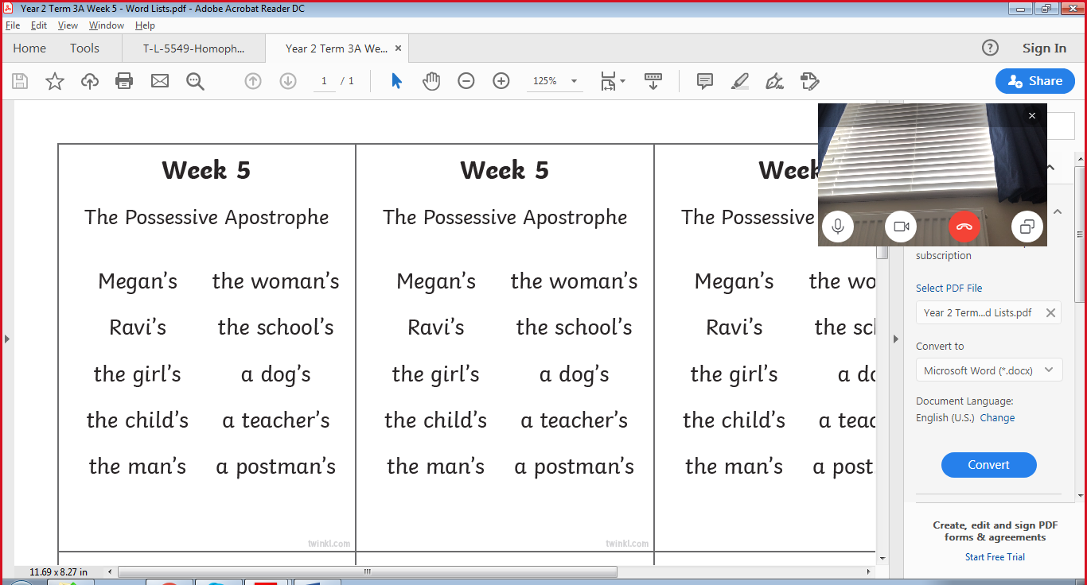
This week’s spellings are:

Please find an attached spelling activity for this week’s spellings in our home learning week 9 folder on our class page.

English/History/ICT
In today’s English lesson, I would like you to research using the internet Grace Darling. Please find and save a picture of her whilst researching these questions.
Who was Grace Darling?
Where did she live?
Why is she famous?
What did she do on 7th September 1838?
What reward did she get? And who form?
What organisation is mostly attached to her?
Please type your answers to the question to improve your ICT skills and save them in a document called Grace Darling. Parents you may need to help and support your child.
Maths
Look around you and pick two 2D shapes that you can see. It might be a circle and a triangle. Now I want you to compare the two 2-D shapes.
What is similar about them and what is different?
Below are some familiar 2D shapes
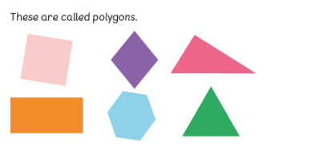
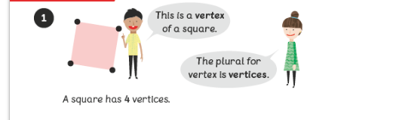
Polygons are 2-D shapes with straight sides.
The 'vertex' is the point where the 2 sides meet in the 2-D shapes. The plural for vertex is vertices. We usually describe as 'corners' of a 2-D shape are called 'vertices'.
Your task today is to identify the number of vertices in a variety of 2-D shapes.
See activity included – Identifying vertices

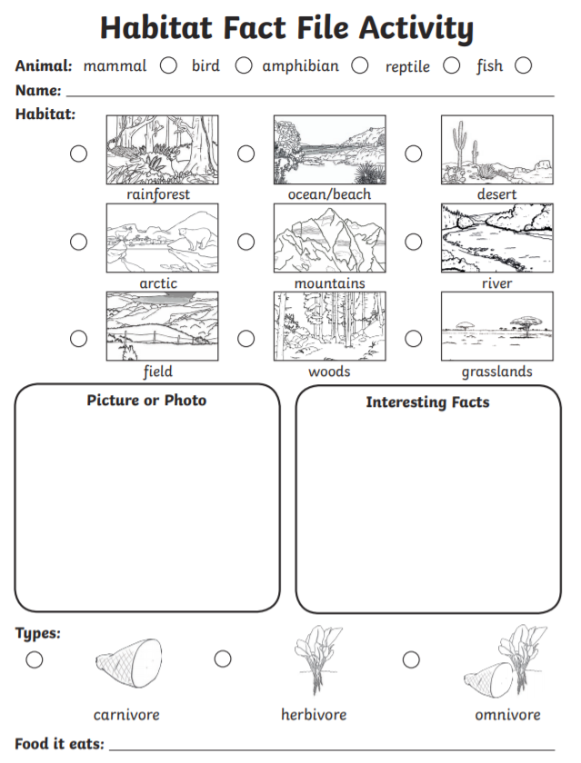
Science
Building on your knowledge of Habitats from last week. Please follow the link to BBC Bitesize and watch the video clips and remind yourself of some of the different habitats. Once you have re-watched the videos please look at activity 2 and complete the attached Habitat Fact File.
https://www.bbc.co.uk/bitesize/articles/zhvmt39

