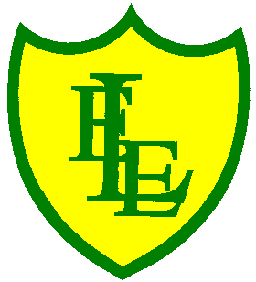
ECCLESTON LANE ENDS
SCHOOL CLOSURE WORK
YEAR: 2
DATE: Friday 5th June 2020

PE: 9-9.30am
Log in to YouTube at 9am to access a 30-minute PE lesson with Joe Wicks, the body coach. https://www.youtube.com/user/thebodycoach1 Also, take a look at the keeping active and mindful website Fitter Future, for some different activities to stay active during this time.

Reading
Today, please read the text about minibeasts. Your garden, like for birds, can also be a habitat for certain insects. The text will give you an idea of where else you might find different minibeasts. Please complete the questions once you have read the text.

Spellings
This week’s spellings challenge was the months of the year.
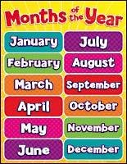

I have uploaded a video for you to test your knowledge on this week’s spellings.
Get your Pencil and paper at the ready and GOOD LUCK!!

I have also uploaded some handwriting practise based on these spellings.

English
Today’s English task is to understand what suffixes are, be able to identify them in words and start using them in your writing. This lesson includes: a video explaining suffixes and three activities to complete all in your home learning journal.
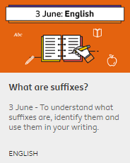 https://www.bbc.co.uk/bitesize/articles/z6vc86f
Maths
Our next maths topic is all about shape. To start with, we will be focusing on 2D shapes. Today I would like you to make a list of the 2D shapes that you can spot in your home. Are there any others that you know of? After that, talk about the differences you notice when comparing the shapes. Think about things such as names, colours, sizes, sides and corners. Activity included – Identifying sides

Extension- If you fancy a challenge, why not try the BITESIZE Year 2 Maths Challenges –Week 6.

Design Technology
This week we have a DT seaside focus. Your task today is to design and if possible create your own ‘savoury’ (not sweet) seaside snack (This could maybe be done at a later date). This is your chance to get really creative, as long as you stick to the brief in that your snack is 1. Savoury and 2. Based on a sea creature. I have attached some photo ideas for both sea creatures and savoury snack ideas based on this theme.
Your savoury snack could be a sandwich, a wrap, a cracker, a rice cake, a pancake or even a bread pinwheel! I have attached a recipe for a bread pinwheel but you can design/create whatever you want to!
Please email Mrs Farrell your creations! We can’t wait to see them!!!
