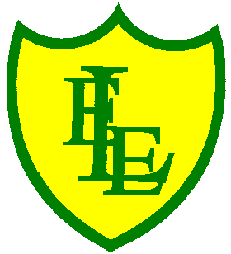
ECCLESTON LANE ENDS
SCHOOL CLOSURE WORK

YEAR: 2
DATE: Thursday 4th June 2020

PE: 9-9.30am
Log in to YouTube at 9am to access a 30-minute PE lesson with Joe Wicks, the body coach. https://www.youtube.com/user/thebodycoach1 Also, take a look at the keeping active and mindful website Fitter Future, for some different activities to stay active during this time.

Reading
Please read the information text about the different birds that you might find in your garden. Your garden might be a habitat for one or more of these birds. Have you spotted any while you’ve been at home? Once you have read the text please complete the questions based on the information you have read.

Spellings
This week’s spellings are based on the months of the year. Why don’t you practise writing them out of order to make sure you know the correct spelling.
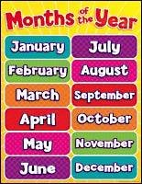

ALSO-Please find an attached spelling activity for this week’s spellings in
home learning week 8.

English
Today’s English task is to understand how to use coordinating conjunctions
because, if and when in sentences. This lesson includes: a video explaining coordinating conjunctions and three activities to do at home. Please complete in your home learning book.

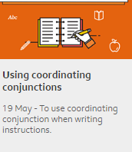
https://www.bbc.co.uk/bitesize/articles/zjdxhbk

Maths
Today’s objective in maths is to revise your times tables in and out of order. Here are some links for games, activities and tasks based on your time tables (2,5,10,11 and possibly 3s).

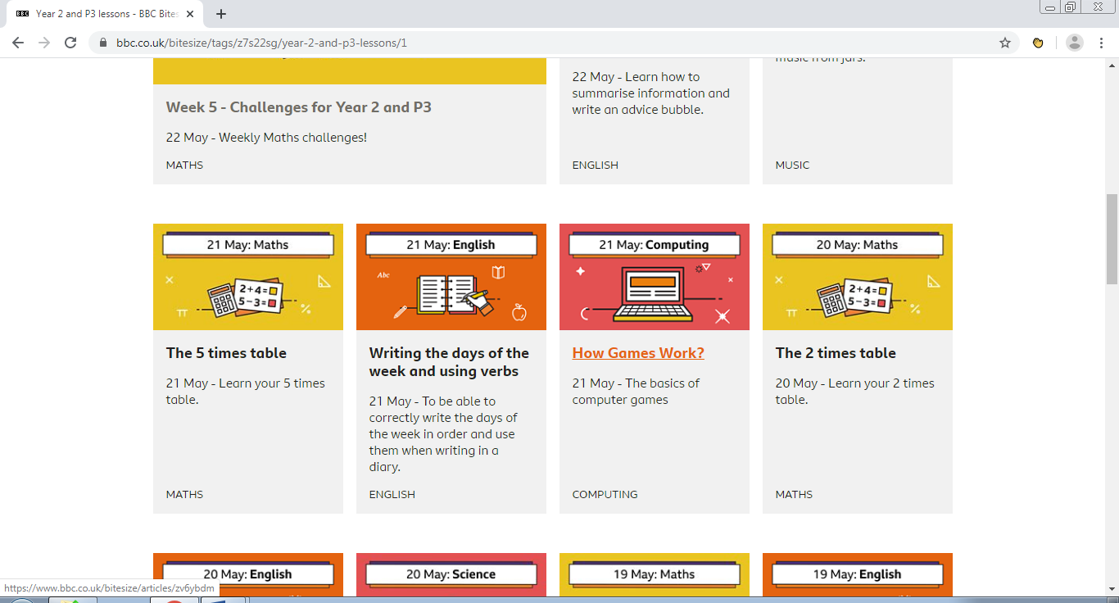https://www.bbc.co.uk/bitesize/articles/zhn6pg8
https://www.bbc.co.uk/bitesize/articles/z7hdqp3
Extension- If you fancy a challenge, why not log onto Times Table Rock Stars and try and compete in our Year 2 tournament!! All times tables have been set for this week.
Well done to all the children that have been logging on regularly. I do update the website each week to provide you with new challenges and to keep your times tables ticking!!!!

Religious Education
Watch the video clip to learn about the Christian festival Pentecost. Pentecost celebrates what happened in Jerusalem 50 days after the resurrection of Jesus at Easter. This year Pentecost was celebrated on Sunday 31st May.
https://www.youtube.com/watch?v=IqG_lvZhU-A&feature=emb_logo

Here are some ideas of craft activities you could do linked to the festival Pentecost.

