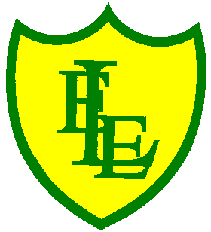
ECCLESTON LANE ENDS
SCHOOL CLOSURE WORK
YEAR: 2
DATE: Friday 22nd May 2020
PE: 9-9.30am
Log in to YouTube at 9am to access a 30-minute PE lesson with Joe Wicks, the body coach. https://www.youtube.com/user/thebodycoach1 Also, take a look at the keeping active and mindful website Fitter Future, for some different activities to stay active during this time.
Reading
Remember in Year 2 we should be reading at home as much as possible but preferably for 15-20 minutes every day.
Please read the final chapter of the story ‘Wolf’s New Friends’. Today in chapter 5, Wolf makes new friends at the park.
https://www.purplemash.com/

Spellings
I have uploaded a video for you to test your knowledge on this week’s spellings.
Get your Pencil and paper at the ready and GOOD LUCK!!

I have also uploaded some handwriting practise which includes all the spelling sentences from this week’s quiz.
Why not record on our spelling blog what you scored!!!

English
For today’s final piece of poetry work for the half term I would like to create an acrostic poem for your name and write some of the things you like to do. Remember how we write an acrostic poem each of the words spell out a word in this case your name. I have made one of my school name. Each of the yellow words spell out Mrs Clarke. I have then told you some information about me and my family. I have told you what I like to do. Please complete in your home journal book. 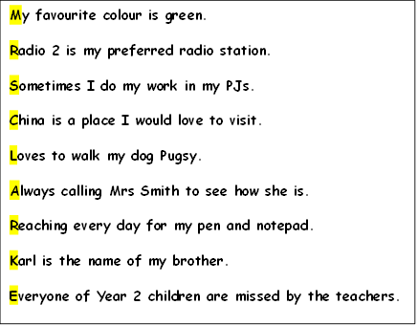

Maths
Following on from yesterday, whereby you worked on solving problems based on either addition or subtraction, today your task is to be able to solve word problems based on either multiplication or division.
Top tip – Read the problem carefully and circle the numbers in the problem.
Then think about the language the problem uses to decide whether it is asking you to multiply or divide the numbers.
For example the words like ‘how much’ usually indicate mulplication, whereas
‘shared equally’ usually indicates division.

Extension- If you fancy a challenge, why not have a go at the mind workout based on volume.

Creative Activity
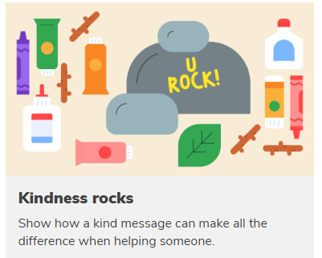

You will need
- Paint
- Paint brushes
- Permanent markers
- Smooth rock (make sure you don't take these from a beach, you can get them from your garden or on your travels).

Kindness rocks should have kind messages written on them and then the idea is that you leave it in a place for others to find.
- Begin to paint your rock.
- While your rock is drying, think of a kind message that would make someone smile, to write on your rock.
Some good examples of messages might be:
  - Be kind.
  - Be happy.
  - Be brave.
  - A friend in need is a friend indeed.
  - Don’t worry, be happy.
- Once they are dry, write a message on your rock.
- Decide with your family whether to place the rock somewhere in the local community or whether to give it to someone you know to make them happy.

Half term challenge
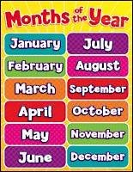
For over the half term why don’t you challenge yourself to learn and practise the months of the year words to spell? How many do you already know? Can you spell them all correctly by the end of the week?

You have all completed another half term at home and once again we are so proud of you all. Have a lovely relaxing half term. Fingers crossed the weather will still stay lovely and you can get out in your garden or take a walk with your family. Parents thank you for your continued support in the home learning of your child. We are missing all of the families of Year 2.

