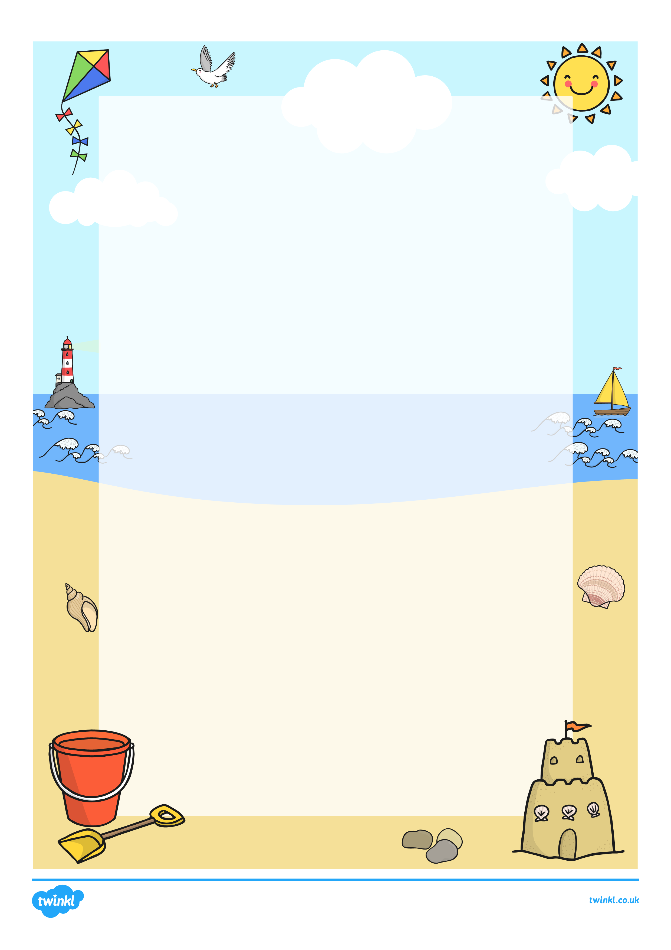
S_________
E_________
A_________
S_________
I_________
D_________
E________

