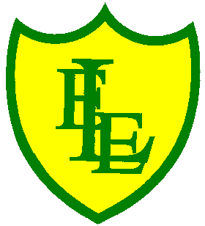
ECCLESTON LANE ENDS
SCHOOL CLOSURE WORK

YEAR: 2
DATE: Thursday 21st May 2020

PE: 9-9.30am
Log in to YouTube at 9am to access a 30-minute PE lesson with Joe Wicks, the body coach. https://www.youtube.com/user/thebodycoach1 Also, take a look at the keeping active and mindful website Fitter Future, for some different activities to stay active during this time.

Reading
Remember in Year 2 we should be reading at home as much as possible but preferably for 15-20 minutes every day.
Please continue to read the story ‘Wolf’s New Friends’. Today in chapter 4, Ned has a great idea!
https://www.purplemash.com/

Spellings
This week’s spellings are:

Please find an attached spelling activity for this week’s spellings in
home learning week 7.

English
Today in English you will be creating your own acrostic poem based on the letters of the seaside (template uploaded). We have looked at acrostic poems earlier in the year when we did our British Values poetry week. Remember an acrostic poem is a poem which the first letter of each line spells out a word, name, or phrase when read vertically. Each line starts with a capital letter that spells out the poem's theme vertically. Acrostic poems don't need to rhyme, but all the other poetic devices like alliteration, similes and rhythm are great if used too. Here is an example.

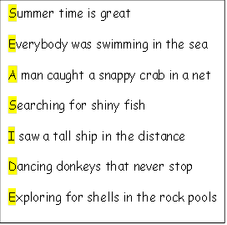
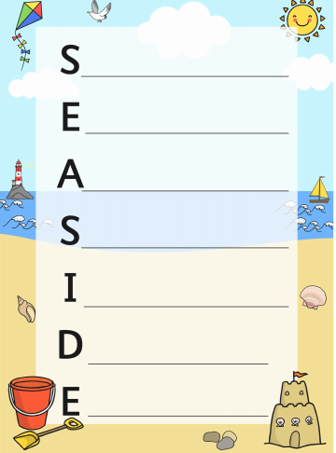

Maths
Following on from comparing volumes and measuring in both litres and millilitres, today your task is to be able to solve word problems on volume. The word problems contain questions about volumes of water in litres and each problem is based on either addition or subtraction.
Top tip – Read the problem carefully and circle the numbers in the problem.
Then think about the language the problem uses to decide whether it is asking you to add or subtract the numbers. For example the words ‘altogether’ usually indicates an addition, whereas ‘what is left’ indicates a subtraction.

Extension- If you fancy a challenge, why not have a go at the two step volume problems that require you to work out two things to get to the answer. These challenges are also either addition or subtraction.

Spanish
Here is a link to one of our favourite numbers and colour songs we like to sing in school. Watch, listen to and join in with the song as much as you can. https://www.youtube.com/watch?v=ZiNFXntWOJw

Now click on this link to play some Spanish colour games. https://www.education.vic.gov.au/languagesonline/spanish/topic04/index.htm
1) Play activity one - Colorea las carros. This is great for your listening skills. Try to colour as many cars as you can correctly. There are lots of colours in this game so listen very carefully to our new colour words. Try your best and remember I am so proud of you if you can remember some of the Spanish colours we have already learned in class.
2) Listen to activity 2 - The song 'Los Colores'. Listen out for as many colours as you can. Choose an action to do when you hear a colour word. Maybe you could stand up or put your hand in the air when you hear a colour.
(Listen out for blancos, grises, roja, negra, rosado, morado).

Georgraphy
I have included a fun multiple-choice quiz based on the revision of our continents learning.
I know that this Geography topic was one of your favourites.
https://www.educationquizzes.com/ks1/geography/continents-of-the-world/
Let’s see how much you can remember.

