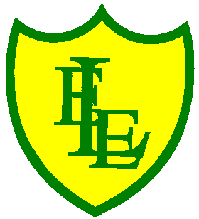
ECCLESTON LANE ENDS
SCHOOL CLOSURE WORK

YEAR: 3
DATE: 15th May 2020

Reading
Login to Purple Mash and read chapter 4 of ‘School Swap’ and complete the quiz. I have also put some open ended questions and sequencing on the website.

Spellings

Practise your spellings for this week.
woman | wonder | month | govern | brother
another | shovel | above | Monday | discover

English Task
I hope you enjoyed Chapter 4 of ‘School Swap’.

At the end of the chapter, Jay has regained control of the class and has managed to give Mr Jones a detention. Will the two characters be able to swap back to their bodies? What problems might they have? Write the next part of the story.

Maths
Make sure that you spend some time on TT Rockstars today.

Complete today’s converting pounds and pence worksheet I have put on the class page. Watch this video to help guide you https://vimeo.com/413284193

Keep playing on Prodigy Maths or Sumdog.

Spanish
This week I would like you to revisit animal nouns. Have a go at this sunshine sparkler activity. You could also look at the following sections on the home learning sheets already uploaded - the pets section on the home learning grid (stage 1) and the animals retrieval exercise on the retrieval home learning sheet.

PHSE
Login to Purple Mash and design a certificate for somebody who has made a difference in your life.

Geography
Logon to Purple Mash. Can you place the countries, capital cities, cities of the UK on a map? Can you also correctly place the counties of England on a map?

I hope you are all well and staying safe.

