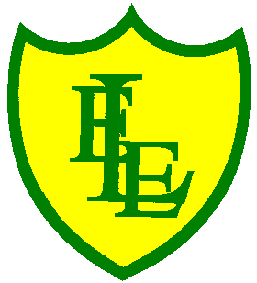
ECCLESTON LANE ENDS
SCHOOL CLOSURE WORK
YEAR: 2
DATE: Tuesday 19th May 2020

PE: 9-9.30am
Log in to YouTube at 9am to access a 30-minute PE lesson with Joe Wicks, the body coach. https://www.youtube.com/user/thebodycoach1 Also, take a look at the keeping active and mindful website Fitter Future, for some different activities to stay active during this time.

Reading
Remember in Year 2 we should be reading at home as much as possible but preferably for 15-20 minutes every day.
Please continue to read the story ‘Wolf’s New Friends’. Today in chapter 2, Wolf and Ned have fun playing in the park.
https://www.purplemash.com/

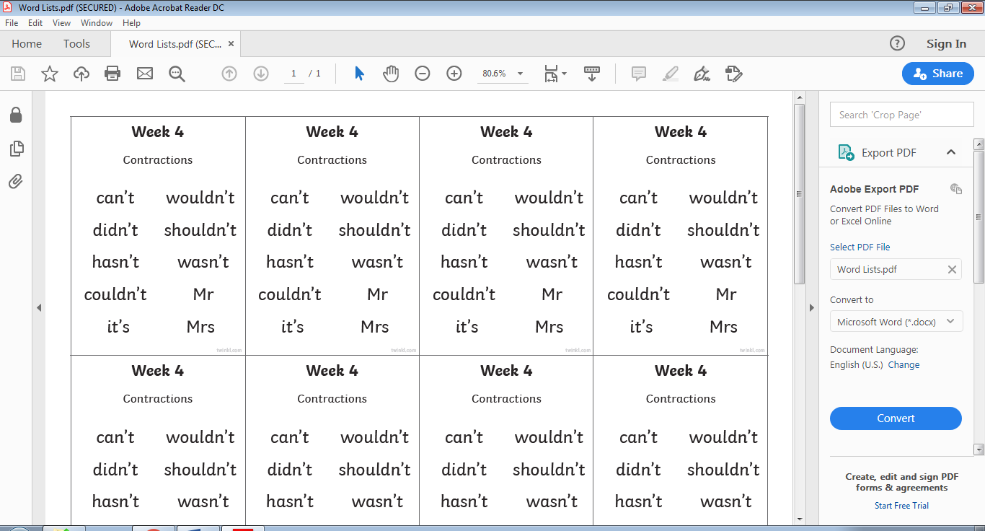
Spellings
This week’s spellings are:

Please find an attached spelling activity for this week’s spellings in
home learning week 7.

English This task is continuing on from yesterday
For your task today, continue with you ‘shape poetry’ of the sea/ocean. Continue to write your poem on the template or in your home learning journal. Remember to include the punctuation and grammar as shown on the PowerPoint. (It is still there from yesterday should you need it for reference).

Maths
Following on from yesterday’s learning and comparing volumes with < > and = (non-standard units of measure), today your task is to be able to be able to measure volume in litres. We write 'l' for litre. Can you find a container that contain liquid measured in litres (1 l, 2 l,3 l) ?
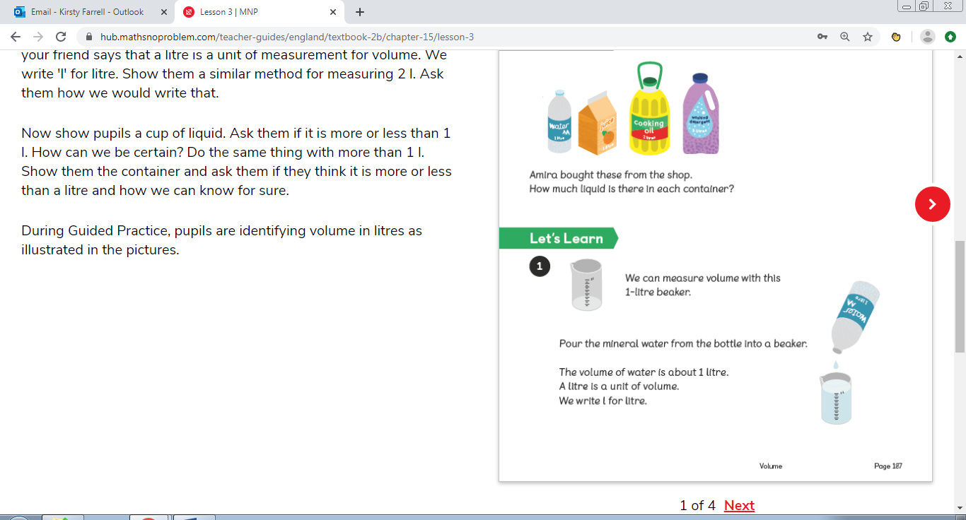
Your task for today is to compare volumes of liquid and determine whether an amount is more than, less than or equal to a litre.
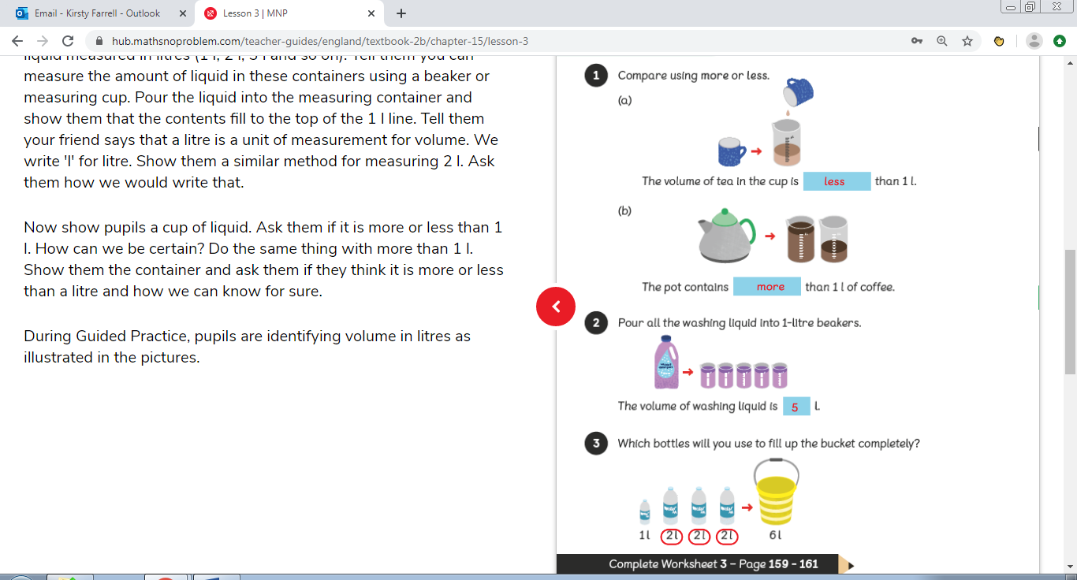
Science
Use the following link to play the BBC Bitesize Science game, Galaxy Pugs. Test your knowledge on different science topics by choosing a topic we have studied and playing the games. Please start with Plants. https://www.bbc.co.uk/games/embed/galaxy-pugs?exitGameUrl=http%3A%2F%2Fbbc.com%2Fbitesize%2Farticles%2Fzn7bscw

P.E Competition
St Helens council have launched a competition to ‘create your own game or challenge’. The idea being to keep yourself and your family active whilst at home. All entries will receive a ‘Schools Games’ certificate and the ones chosen for the competition will receive a medal and a T-shirts. Further details and rules of the competition are attached. Have fun and good luck!!!!

