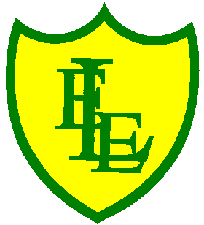
ECCLESTON LANE ENDS
SCHOOL CLOSURE WORK
YEAR: 2
DATE: Monday 18th May 2020

PE: 9-9.30am
Log in to YouTube at 9am to access a 30-minute PE lesson with Joe Wicks, the body coach. https://www.youtube.com/user/thebodycoach1 Also, take a look at the keeping active and mindful website Fitter Future, for some different activities to stay active during this time.

Reading
Remember in Year 2 we should be reading at home as much as possible but preferably for 15-20 minutes every day. This should be a book that you read for pleasure.
This week we have set you another reading activity on purple mash (see the 2Do section).
We have allocated you the story ‘Wolf’s New Friends’. Please read a chapter each day then complete the short quiz and activities about what you have read. Today, in Chapter 1, Wolf and Ned are busy playing computer games when Dad asks them to go to the park with him.
https://www.purplemash.com/

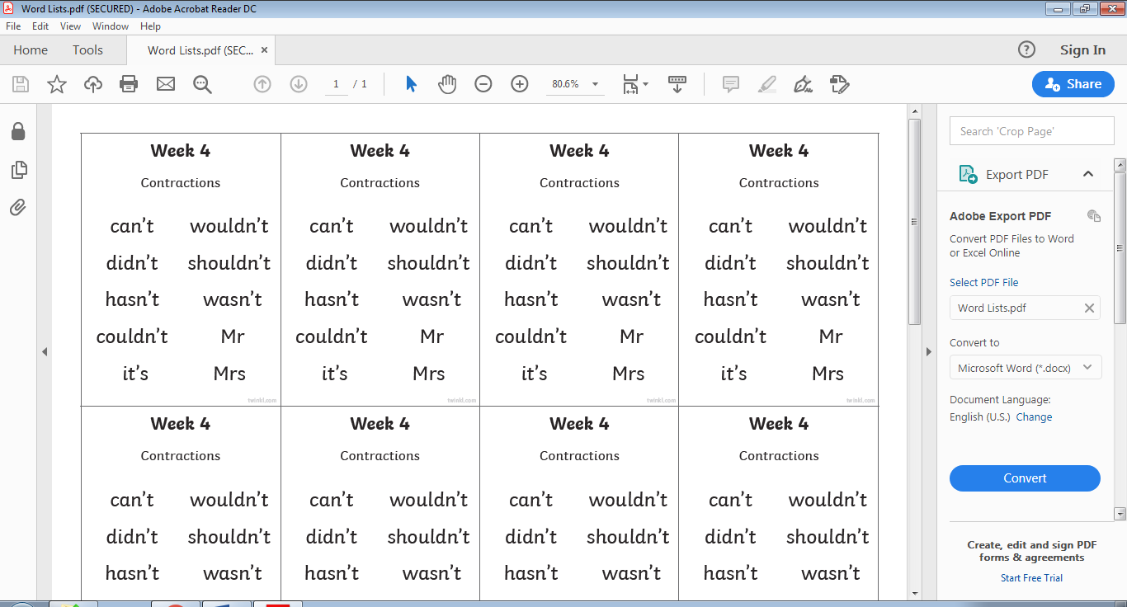
Spellings
This week’s spellings are:

Please find an attached spelling activity for this week’s spellings in our home learning week 7 folder on our class page.

English This task is over two days
For your task today and tomorrow it is all about ‘shape poetry’ of the sea/ocean. Parents please read the power point to your child, discussing each slide in depth. I have uploaded shape poetry templates. You need to choose a design and begin to plan your poem. I am not expecting this to be finished today, this task is over two days. Plan and take your time.

Maths
This week in maths we will be learning all about volume. Today your task is to be able to compare and order volume and record the results using > (greater than),
< (less than) and = (equal to) rather than standard units of measurement.
For example:
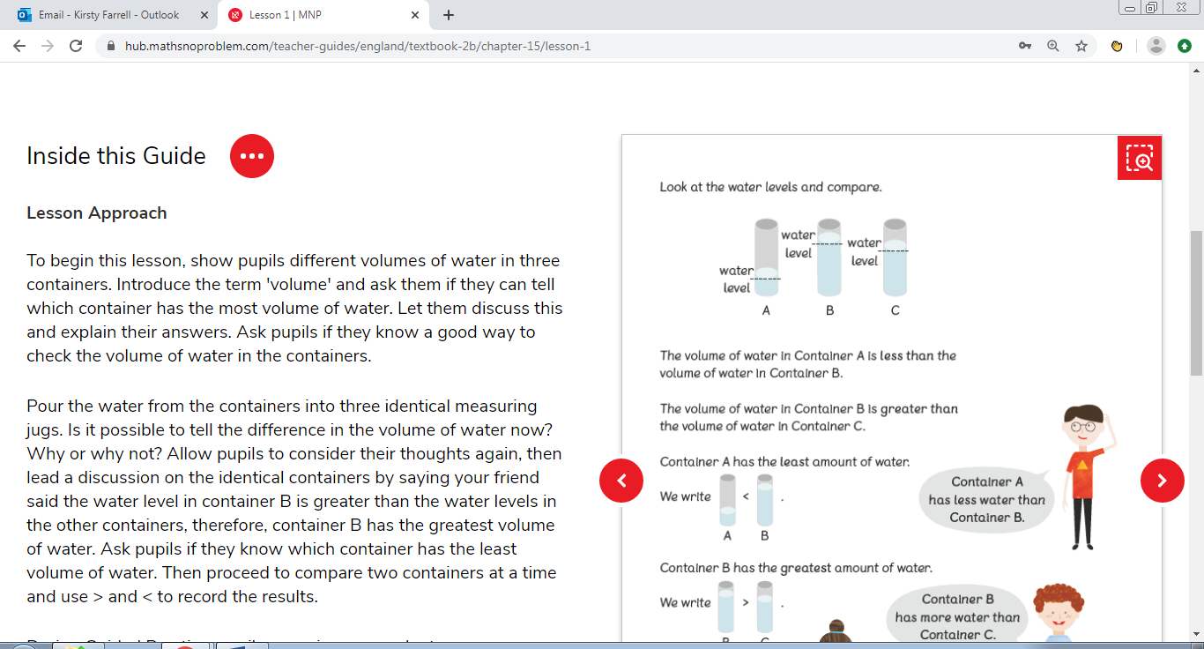
Let’s experiment - Why don’t you find 3 identical sized containers at home and fill them up with different amounts of liquid. Can you compare them? Which one is < than another? Which one is > than another? Can you make the volume of two containers = to one another?

Science
To conclude our Science work on plants, today we would like you to think about what plants we can eat and what parts of the plant we eat. Follow the link to watch the video to find out which parts of plants can be eaten. https://www.youtube.com/watch?v=ksVbfkY6uKM
After you’ve watched the video clip please complete the following activity sheet.

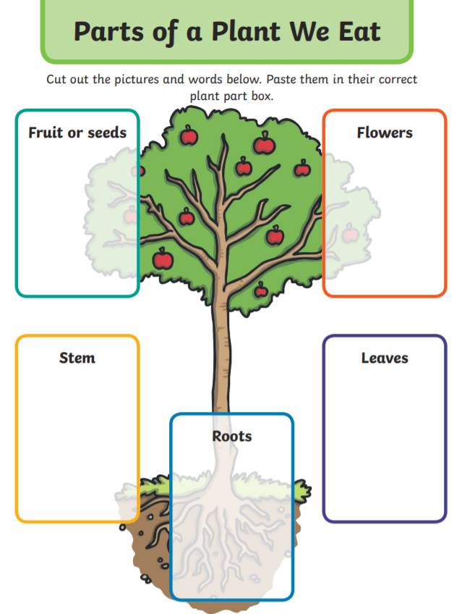

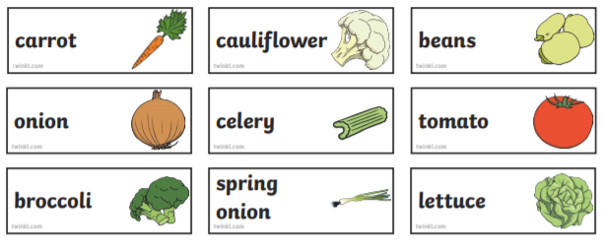

If you can print this sheet great. If not, no problem, you could just write the different subheadings (fruits or seeds, flowers, leaves roots & stem) in your home learning exercise book and draw and label the different parts of the plant under the correct heading.
Challenge: Can you think of any other parts of plants we eat that haven’t been mentioned and put them under the correct subheading?

