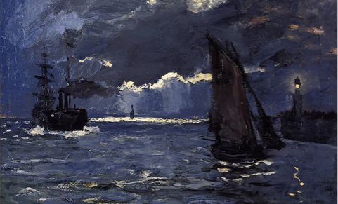
Claude Monet - ‘Shipping by Moonlight’:

