
ECCLESTON LANE ENDS
SCHOOL CLOSURE WORK

YEAR: 2
DATE: Friday 15th May 2020
PE: 9-9.30am
Log in to YouTube at 9am to access a 30-minute PE lesson with Joe Wicks, the body coach. https://www.youtube.com/user/thebodycoach1 Also, take a look at the keeping active and mindful website Fitter Future, for some different activities to stay active during this time.
Reading
Remember in Year 2 we should be reading at home as much as possible but preferably for 15-20 minutes every day.
Today, please read the final chapter of the story ‘Little Red’, set on Purple Mash. Once you have read chapter 5, complete the short quiz and activities about what you have read. https://www.purplemash.com/

Spellings
I have uploaded a video for you to test your knowledge on this week’s spellings.
Get your Pencil and paper at the ready and GOOD LUCK!!

I have also uploaded some handwriting practise which includes all the spelling sentences from this week’s quiz.
Why not record on our spelling blog what you scored!!!

English
Today’s lesson will be writing a short story using the five senses. You need to watch the video of ‘Adventures at the seaside’ with the Brown Family and Paddington bear. Once completed using your home learning book write about what Paddington may see, smell, hear, touch and taste at the seaside. You can use some the information from the story clip or challenge yourself to think of some more. We are looking or a wide range of punctuation including similes, adverbs and conjunctions.
https://www.youtube.com/watch?v=2MK8OGNiTG8
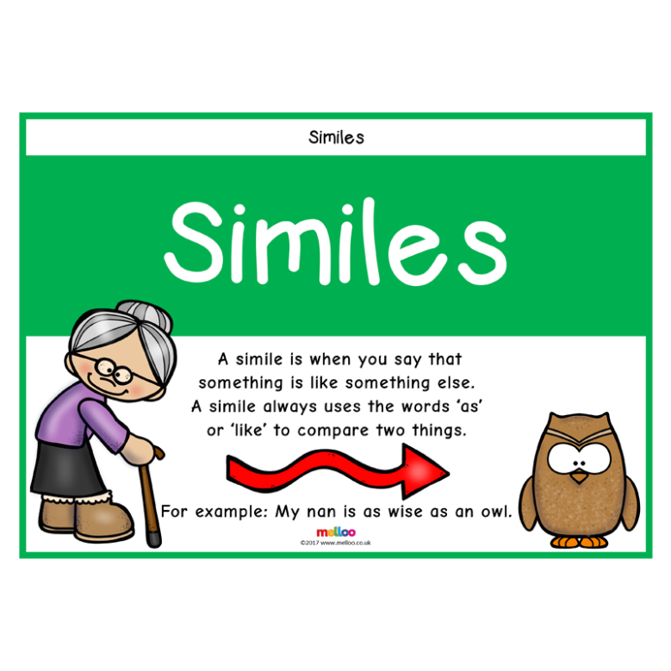
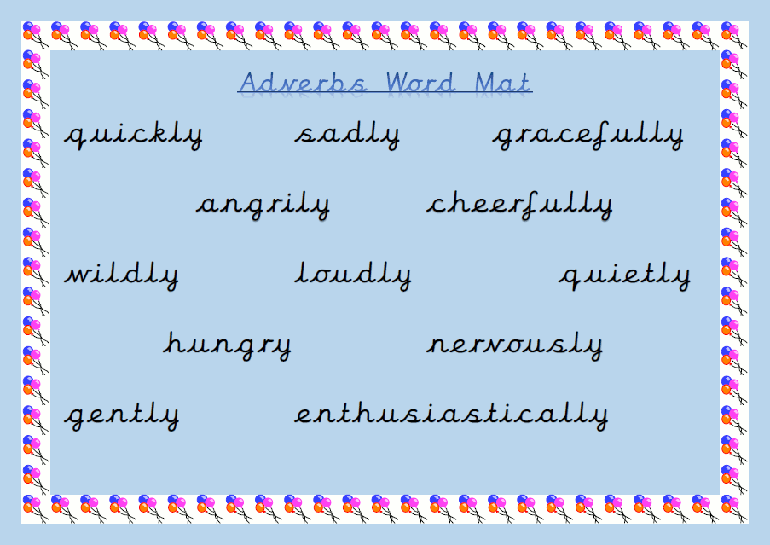
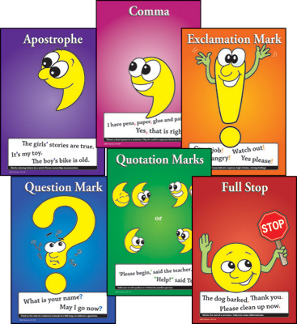
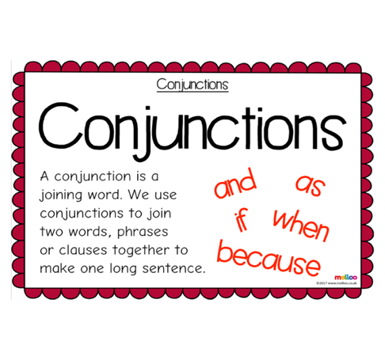
Maths
Today I have included a number of word problems with money challenge cards to test your knowledge on our money topic. These challenges include aspects of money we have worked on throughout the last two weeks to consolidate your learning.

Extension- If you fancy a challenge, why not have a go at the BBC BITESIZE maths year 2 weekly challenges 15.5.20 at
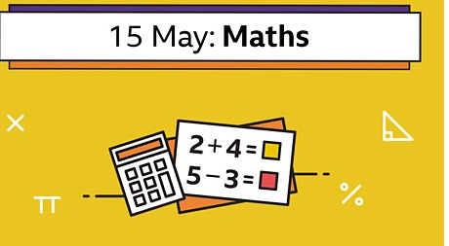
https://www.bbc.co.uk/bitesize/articles/zd4w7nb

Art & Design
Do you remember last week when you were asked to explore and comment on one of
L S Lowry’s famous seascape paintings? Well today you will be asked to study another famous seascape painting by other very famous artist. You might of heard of him; Claude Monet.
Here is a seascape painted by Monet called ‘Shipping by Moonlight’:
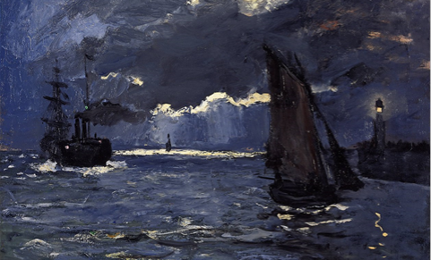
Your task today is to study this painting and ask yourself the following questions:
(If possible print this picture of and write the answers around it, if not look at the image on screen and write you answers in your home learning book)

Do you like this painting? Why?
How does it make you feel?
Where do you think it is set?
Can you describe what you can see?
Can you see any typical seaside features?
Is there anything similar between this seascape and LS Lowry’s seascape?
What is different between this seascape and LS Lowry’s seascape?
How have they painted them differently?

Challenge – Can you do some of your own research on the amazing Claude Monet?

Have a lovely weekend. We hope you are missing us all as much as we are missing your smiling faces.

