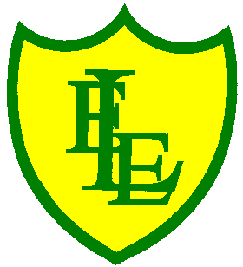
ECCLESTON LANE ENDS
SCHOOL CLOSURE WORK

YEAR: 2
DATE: Thursday 14th May 2020

PE: 9-9.30am
Log in to YouTube at 9am to access a 30-minute PE lesson with Joe Wicks, the body coach. https://www.youtube.com/user/thebodycoach1 Also, take a look at the keeping active and mindful website Fitter Future, for some different activities to stay active during this time.

Reading
Remember in Year 2 we should be reading at home as much as possible but preferably for 15-20 minutes every day.
Please continue with reading the story ‘Little Red’, set on Purple Mash. Today is chapter 4. Then complete the short quiz and activities about what you have read. https://www.purplemash.com/

Spellings
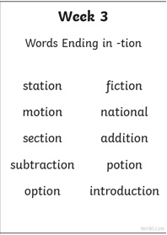
This week’s spellings are:

Please find an attached spelling activity for this week’s spellings in
home learning week 6.

English
Today’s task is to write a message in a bottle that you have discovered on a beach, please see enclosed sheet. You can write the message on the computer to improve your IT skills or in your home learning book. Use lots of great language in your writing and fabulous vocabulary. We look forward to reading them.

Maths
For today’s activities, follow the BBC Bitesize link below for the lesson on ‘working out how much change’. The link consists of a video and interactive activities to complete on line.
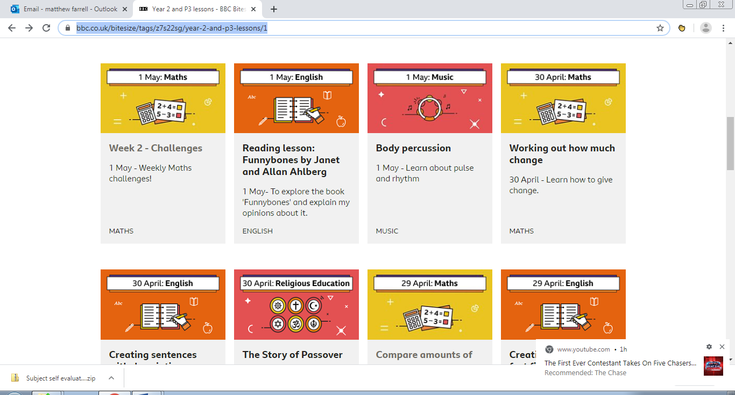 https://www.bbc.co.uk/bitesize/articles/z6gthbk

Extension- If you fancy a challenge, why not complete the challenges based on working out change. Questions to support finding change with amounts in multiple of 10 pence. Then questions develop to include amounts with multiples of 10 pence up to £1.

Spanish
This week I would like you to practise and learn colours in Spanish. Click on this link and join in with Irene. Try hard to learn the action for each colour word.
https://www.youtube.com/watch?v=I1g9Lgo9hH0&list=PLXMCXZunVHHfwnML1lvT0dNyyfsOKn06y&index=3
Mrs Orledge

You can't use up creativity. The more you use, the more you have.
Maya Angelou

