Message in a bottle
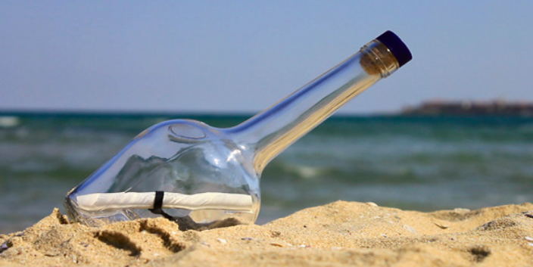
The sand felt warm under my feet as I strolled along the long, golden beach. The waves were crashing against the shore, and with them, brought something that glistened in the hot, boiling sunshine. It rolled towards my feet. As I looked down, I saw a clear bottle. I picked up the bottle………
Finish the story, what is the message in the bottle?
__________________________________________________________________________________________________________________________________________________________________________________________________________________________________________________________________________________________________________________________________________________________________________________________________________________________________________________________________________________________________________________________________________________________________________________________________________________________________________________________________________

