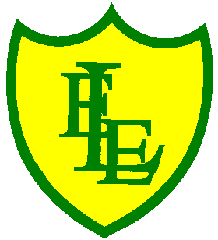
ECCLESTON LANE ENDS
SCHOOL CLOSURE WORK

YEAR: 3
DATE: 11th May 2020

Reading
Login to Purple Mash and read chapter 6 ‘Sleeping Volcano’ and complete the quiz. I have also put some open ended questions and sequencing on the website.

Spellings

Practise your spellings for this week.
woman | wonder | month | govern | brother
another | shovel | above | Monday | discover

Maths
Make sure that you spend some time on TT Rockstars today.

Complete today’s adding fractions worksheet I have put on the class page. Watch this video to help guide you https://vimeo.com/402858285

Keep playing on Prodigy Maths. I have also put a link on for SUMDOG. Ask your parent to set up a parent account and to add you.

