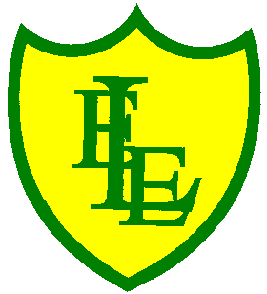
ECCLESTON LANE ENDS
SCHOOL CLOSURE WORK

YEAR: 3
DATE: 13th May 2020

Reading
Login to Purple Mash and read chapter 2 of ‘School Swap’ and complete the quiz. I have also put some open ended questions and sequencing on the website.

Spellings

Practise your spellings for this week.
woman | wonder | month | govern | brother
another | shovel | above | Monday | discover

English Task
I hope you enjoyed Chapter 2 of ‘School Swap’.

Logon to Purple Mash. Imagine that you are Jay. Write a diary entry about your strange day. What worries or concerns do you have? How does it feel for people to be treating you as a grown up?

Maths
Make sure that you spend some time on TT Rockstars today.

Complete today’s problem solving worksheet I have put on the class page. Watch this video to help guide you https://vimeo.com/405759047

Keep playing on Prodigy Maths or Sumdog.

Spanish
This week I would like you to revisit animal nouns. Have a go at this sunshine sparkler activity. You could also look at the following sections on the home learning sheets already uploaded - the pets section on the home learning grid (stage 1) and the animals retrieval exercise on the retrieval home learning sheet.

PHSE
Login to Purple Mash and design a certificate for somebody who has made a difference in your life.

Geography
Logon to Purple Mash. Can you place the countries, capital cities, cities of the UK on a map? Can you also correctly place the counties of England on a map?

