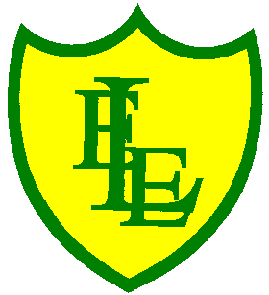
ECCLESTON LANE ENDS
SCHOOL CLOSURE WORK

YEAR: 2
DATE: Wednesday 13th May 2020

PE: 9-9.30am
Log in to YouTube at 9am to access a 30-minute PE lesson with Joe Wicks, the body coach. https://www.youtube.com/user/thebodycoach1 Also, take a look at the keeping active and mindful website Fitter Future, for some different activities to stay active during this time.

Reading
Remember in Year 2 we should be reading at home as much as possible but preferably for 15-20 minutes every day.
In addition, please read chapter 3 of the story ‘Little Red’, set on Purple Mash. Then complete the short quiz and activities about what you have read. https://www.purplemash.com/

Spellings
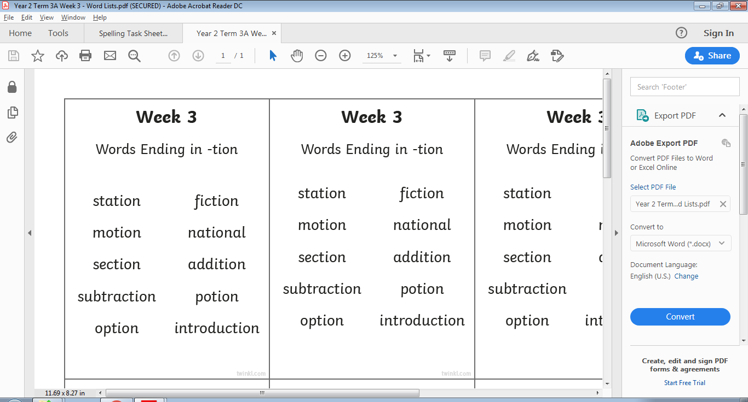
This week’s spellings are:

Handwriting practise sheets for this week’s spellings are available to download on spelling section at the top of our class page.

English- Theme seaside/beach
In today’s English, you will be creating a ‘made up’ postcard to send to a friend or family member. You have to pretend that you are holidaying at the beach or seaside. I have enclosed a power point for your reference to read before you write your postcard. You will need to write an address on the right hand side of the postcard. Talk about what you have been up to. Write about the weather, who you are with, what activities you have done. It is not a story, it should be short sentences informing the person who will receive the postcard. I am assuming that at some point we have all been to the seaside or beach. It could be Formby, Blackpool, Jersey, Bondi or even the Maldives and if you haven’t been to a beach or seaside that’s fine, pretend ask your parents and make up a new location. I would like you to use your home learning books to design and write your own postcard. I have also enclosed template of postcards. You could print one off and use this if you prefer and glue it in your home learning book. The choice is yours.

Maths
Today’s objective in maths is to be able to calculate the total amount of money.
My top tip for word problems is to, first of all, circle the numbers in the question and then figure out what the question is asking you to do (+ - x or ÷). In this case most questions will be based on addition.
To begin with, challenges include questions to support finding the total of different amounts of money, including adding 2 or 3 written amounts with images to support.
Then to extend your learning on page 2, questions include finding the total of different amounts of money by adding up to 3 amounts with written amounts and images to support.

Extension- If you fancy a challenge, why not have a go at page 3. These challenges include questions to support finding the total amount of money but with the use of multiple coins of the same value, written amounts and images.

Georgraphy
This week in Geography, your task is to look at a map of Great Britain and mark out the places that are on the coast and potentially seaside resorts. Use two colours to do this and make two list of places:
Places by the sea
Places NOT by the sea
Once completed, look at your Places by the sea column and decide with family which places are popular British seaside resorts. Have you visited any on the list?
*Have you visited any that are not on your list? If so can you locate them on a map and plot them down using a third colour?

Challenge – I have included a fun multiple-choice quiz based on the revision of our continents learning. I know that this Geography topic was one of your favourites. Let’s see how much you can remember. I have also linked our favourite continents song!!!
https://www.youtube.com/watch?v=K6DSMZ8b3LE

Don’t forget to email us a home learning photograph to be showcased on our school website page. We would love to see you all!

