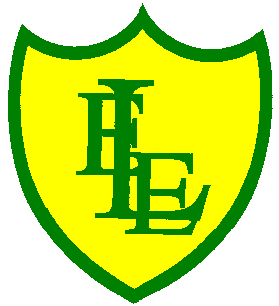
ECCLESTON LANE ENDS
SCHOOL CLOSURE WORK

YEAR: 2
DATE: Tuesday 12th May 2020

PE: 9-9.30am
Log in to YouTube at 9am to access a 30-minute PE lesson with Joe Wicks, the body coach. https://www.youtube.com/user/thebodycoach1 Also, take a look at the keeping active and mindful website Fitter Future, for some different activities to stay active during this time.

Reading
Remember in Year 2 we should be reading at home as much as possible but preferably for 15-20 minutes every day. This should be a book that you read for pleasure.
Also, continue to read the story ‘Little Red’, set on Purple Mash. Please read chapter 2 today then complete the short quiz and activities about what you have read. https://www.purplemash.com/

Computing
Also on Purple Mash, please complete the computing activities linked to the story ‘Little Red’. Activity 1: Pick the Flowers- Use the arrows to move around the screen and help Little Red pick the flowers to take to Grandma. Watch out the wolf is playing in the garden! Activity 2: Chapter 2 Paint Project- Colour the picture of the wolf with a cake. Imagine what kind of cake he may like. Drag the words to make a sentence to describe the picture.

Spellings
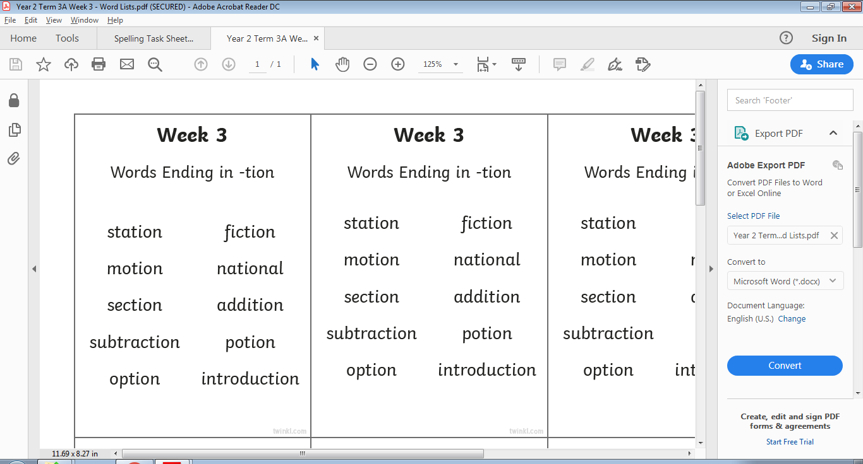
This week’s spellings are:

Please find an attached spelling activity for this week’s spellings in
home learning week 6.

English
Today’s task will be to write a short story to go along with the picture below. This will be an independent fantasy story and we want you to use your imagination, be creative in your writing and use lots of challenging punctuation and grammar. Take some time to think about your story, maybe write some planning points down before you start. Think about what you may write, what direction will your story will take? Do the characters in the story have names? Please write in your home learning journal. Don’t forget to give your story a title.
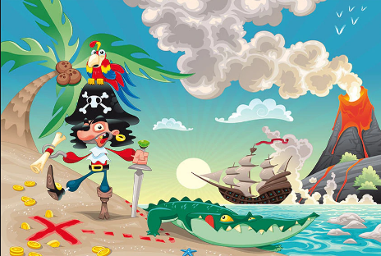

Maths
For today’s activities, follow the BBC Bitesize link below for the lesson on ‘compare amounts of money’. The link consists of a video and interactive activities to complete on line.
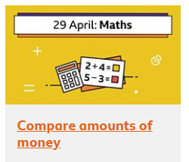 https://www.bbc.co.uk/bitesize/articles/zjxmxyc
Extension- If you fancy a challenge, why not complete the challenges on the attached ‘How much money’ worksheets. There are three different levels starting at level 1 on page 1.

PSHE
Please continue to complete your daily acts of kindness activity for PSHE.

We hope you all had a lovely VE day bank holiday weekend with your families.

