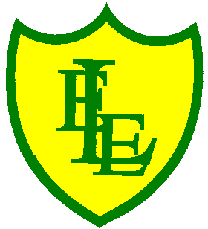
ECCLESTON LANE ENDS
SCHOOL CLOSURE WORK

YEAR: 2
DATE: Monday 11th May 2020
PE: 9-9.30am
Log in to YouTube at 9am to access a 30-minute PE lesson with Joe Wicks, the body coach. https://www.youtube.com/user/thebodycoach1 Also, take a look at the keeping active and mindful website Fitter Future, for some different activities to stay active during this time.
Reading
Remember in Year 2 we should be reading at home as much as possible but preferably for 15-20 minutes every day. This should be a book that you read for pleasure.
This week we have set you another reading activity on purple mash (see the 2Do section).
We have allocated you the story ‘Little Red’. Please read a chapter each day then complete the short quiz and activities about what you have read. Today is Chapter 1.
https://www.purplemash.com/

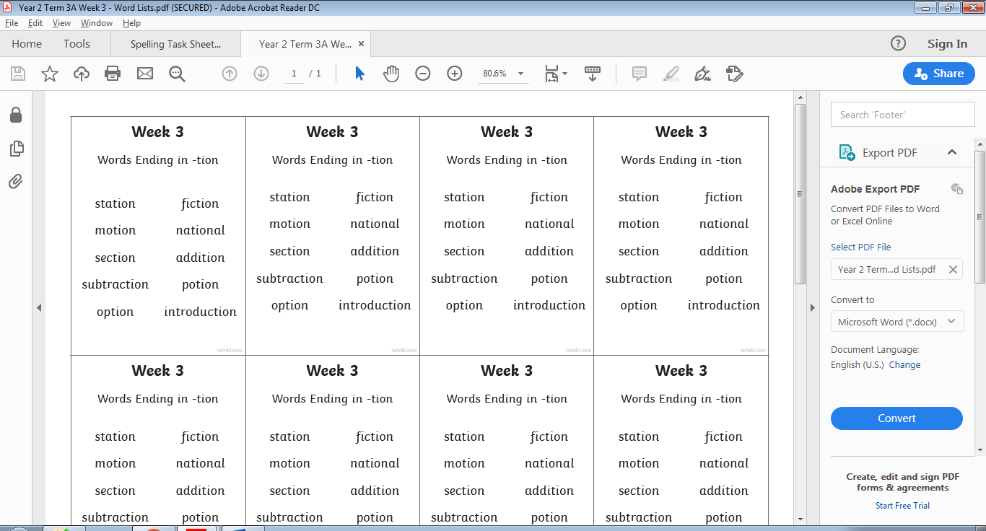
Spellings
This week’s spellings are:

Please find an attached spelling activity for this week’s spellings in our home learning week 6 folder on our class page.

English
Please follow the link below for today’s English lesson. It should take you straight to today’s lesson, if not please see the image and search for this activity under the Y2 English section. You should be able to correctly write command sentences as well as listing items in a sentence.
The lesson includes a video to help you understand listing in sentences as well as a video to teach you about command sentences. Once you have watched the videos please complete the three activities in your home learning journal.
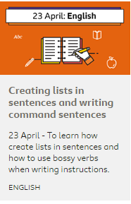
https://www.bbc.co.uk/bitesize/topics/zpbbkqt/articles/zbv72sg
Maths
Today’s objective in maths is to be able to exchange a coin with other coins of different denominations. It is important to note that it must be equal to the value of the original coin (to make the same amount you started off with). For example:
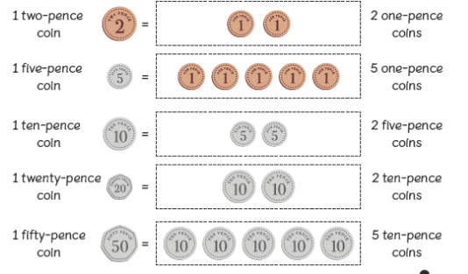
Today’s challenges include questions to support making the same amount using only coins or only notes in each question.
Extension- If you fancy a challenge, why not complete page 2 with questions based on making the same amount of pounds and pence. Challenges also include a variety of coins and notes in the same question.
Science
Continuing with our Science work, learning about plants, please use the following link to watch the two BBC Bitesize clips to find out the basic parts of a plant. https://www.bbc.co.uk/bitesize/articles/zrh8wty
These will tell you the different parts of some plants, the job they do and why they are important. Then complete activity 1 - take the short quiz to see what you have learned.

Don’t forget to send photographs of your completed lighthouses, so we can upload them onto our gallery page of the website.

