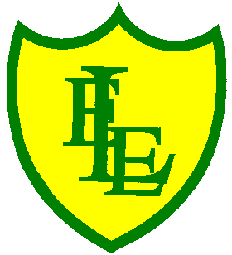
ECCLESTON LANE ENDS
SCHOOL CLOSURE WORK

YEAR: 2
DATE: Thursday 7th May 2020

PE: 9-9.30am
Log in to YouTube at 9am to access a 30-minute PE lesson with Joe Wicks, the body coach. https://www.youtube.com/user/thebodycoach1 Also, take a look at the keeping active and mindful website Fitter Future, for some different activities to stay active during this time.

Reading
Your reading activity today is based on VE Day. Please read the information text ‘Victory in Europe Day’ and then complete the questions based on what you have read.

Spellings
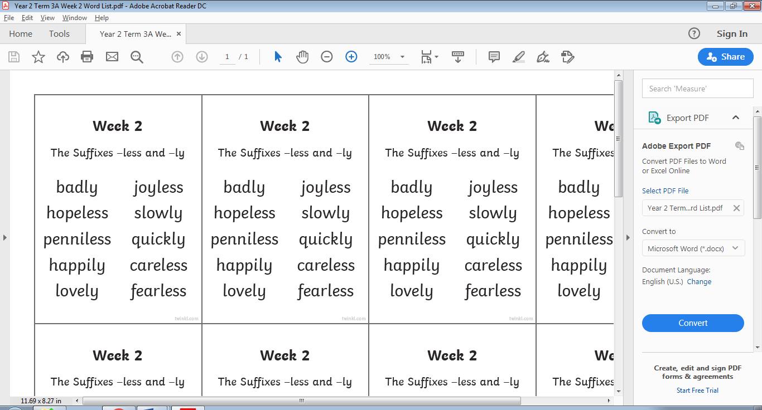
This week’s spellings are:

See attached spelling sentence activity sheet.
Please practise your handwriting as well as filling in the spelling word from this week’s spelling list.
Due to the VE day Bank Holiday tomorrow Friday 8th May, I will upload the spelling test video tonight for your child to watch at their leisure.

English/DT project
For today’s task you will be designing your own lighthouse, you have found out information about lighthouses at the start of the week during your reading task. If we were in school this would happen over stages each week and we would link it to science and electrical circuits. You could use a torch to for the light. I appreciate we are all making this at home; therefore we will be designing and constructing a simple, basic lighthouse. I would like you to make this model within a week and send your pictures with you on the picture into us via emails that were sent out on the letter last week in order for us to show case them on the gallery page of our website. Some children will have paints at home, while other may not, so maybe use felts, oil pastels, crayons, tissue paper, and insulation tape for the stripes. Be creative! It is your design and it is your model. Anything goes on lockdown when you are being artistic and exploring learning.
Maths
For today’s activities, follow the BBC Bitesize link below for the lesson on ‘using coins to make an amount’. The link consists of a video and interactive activities to complete on line.
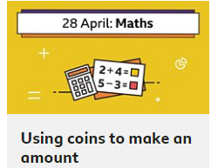
https://www.bbc.co.uk/bitesize/articles/zn4q7nb

Extension- If you fancy a challenge, why not complete the challenges on the attached ‘making money amounts’ worksheets. There are three different levels starting at level 1 on page 1.

Spanish
I would like you to continue practising numbers 1 -10 this week.
https://www.education.vic.gov.au/languagesonline/spanish/topic06/index.htm
Languages Online - Spanish Topic 06
The interactive tasks and printable worksheets in this section of Languages Online focuses on Numbers 1 - 10
www.education.vic.gov.au

Click on this link and then do the activities in the following order:
- Listen and join in with the song 'diez canguros' (activity 2)
- Have a go at 'arrastra los numeros (activity 1)
- Play presiona el boton (activity 4)
For those of you that are looking for an extra challenge have a go at activity 3 Cuantos Cuantos. If you find any of these activities a bit tricky please don't worry. The most important activity is to listen and join i with the song.
Mrs Orledge

Enjoy your bank holiday weekend, stay safe and have fun.
