
ECCLESTON LANE ENDS
SCHOOL CLOSURE WORK
YEAR: 2
DATE: Wednesday 6th May 2020
PE: 9-9.30am
Log in to YouTube at 9am to access a 30-minute PE lesson with Joe Wicks, the body coach. https://www.youtube.com/user/thebodycoach1 Also, take a look at the keeping active and mindful website Fitter Future, for some different activities to stay active during this time.
Reading
Today, please read the information text, ‘Bean Plant Lifecycle’, which again links to our Science work. Once you have read the text please answer the questions about it.

Spellings
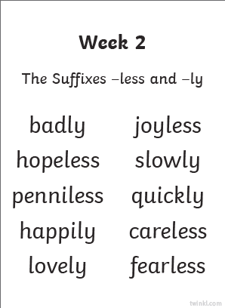
This week’s spellings are:

Handwriting practise sheets for this week’s spellings are available to download on spelling section at the top of our class page.
English
In today’s English lesson you will be completing a book review on the Lighthouses Keeper’s lunch. You can complete this either in your home learning book handwritten or on a word document to practise IT skills.
You need to include:
- Title, author, type of book,
- What age range the book is for? What the book is about,
- Would you recommend this book? If so why? If not why?
- Favourite part of the book? And draw an illustration of this.
- Rate the book using a 5 star rating 1 being poor 5 being excellent.
- Anything else you would like to add

Maths
Today’s objective in maths is to be able to count money in pounds (coins and notes). To begin with, challenges include to support counting money using up to 5 coins or notes of one type. Then to extend your learning on page 2, there are questions to support counting money using up to 10 coins or notes of two types, with some examples of mixed coins and notes used within a question.
Extension- If you fancy a challenge, why not have a go at page 3. These challenges include questions to support counting money using up to three of coins or notes.

Georgraphy
- Watch the BBC Video: ‘A visit to the seaside’ with your friend Barnaby bear, to help you to think about the main features of the seaside. https://www.youtube.com/watch?v=6qO0mu6YJW8

- Spot the Difference: Today we are going to think about how the seaside is the same/different to our own locality. Look at the attached image of our school grounds and compare it to the image of the Blackpool seaside resort.

Questions to think about:
How is the seaside different to our local area?
In what ways might it be the same?
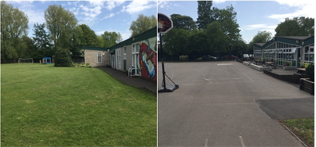
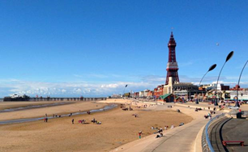

- Features of the Seaside: Now we are going to focus on recognising and naming the key features of seaside locations.
Can you examine the photograph of the seaside attached to class page and ask yourself
the following questions:

What can you see? What do you think is happening here?
What things can you see which are ‘human’ (man-made)?
What things are physical (natural)? What is the weather like?

On the attached worksheet ‘Features of the Seaside’, can you label the key features of a seaside.
Think about natural and man-made features.
There is a word bank on a separate sheet if needed but try to think of at least 5 of your own.

This work can be done over two days if needed.

