The Lighthouse Keeper’s Lunch
Draw and label sandwich fillings to get rid of those Pesky Seagulls.
The more disguising and revolting the better.

mustard
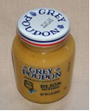

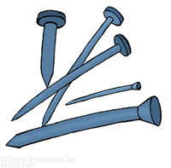
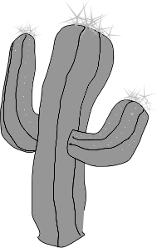
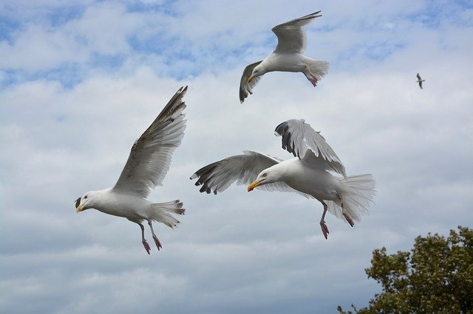

Write what you would include in the sanwich using commas in a list and give an explation what the seagulls will say to each other when they eat the sandwich. Use inverted commas for speech.

______________________________________________________________

_______________________________________________________________________________________________________________________________________________________________
____________________________________________________

