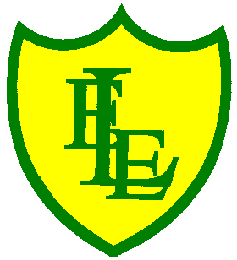
ECCLESTON LANE ENDS
SCHOOL CLOSURE WORK

YEAR: 2
DATE: Tuesday 5th May 2020

PE: 9-9.30am
Log in to YouTube at 9am to access a 30-minute PE lesson with Joe Wicks, the body coach. https://www.youtube.com/user/thebodycoach1 Also, take a look at the keeping active and mindful website Fitter Future, for some different activities to stay active during this time.

Reading
Today, please read the information text, ‘The Lifecycle of a Sunflower Plant’, which links to our Science work. Once you have read the text please answer the questions about it.

Spellings
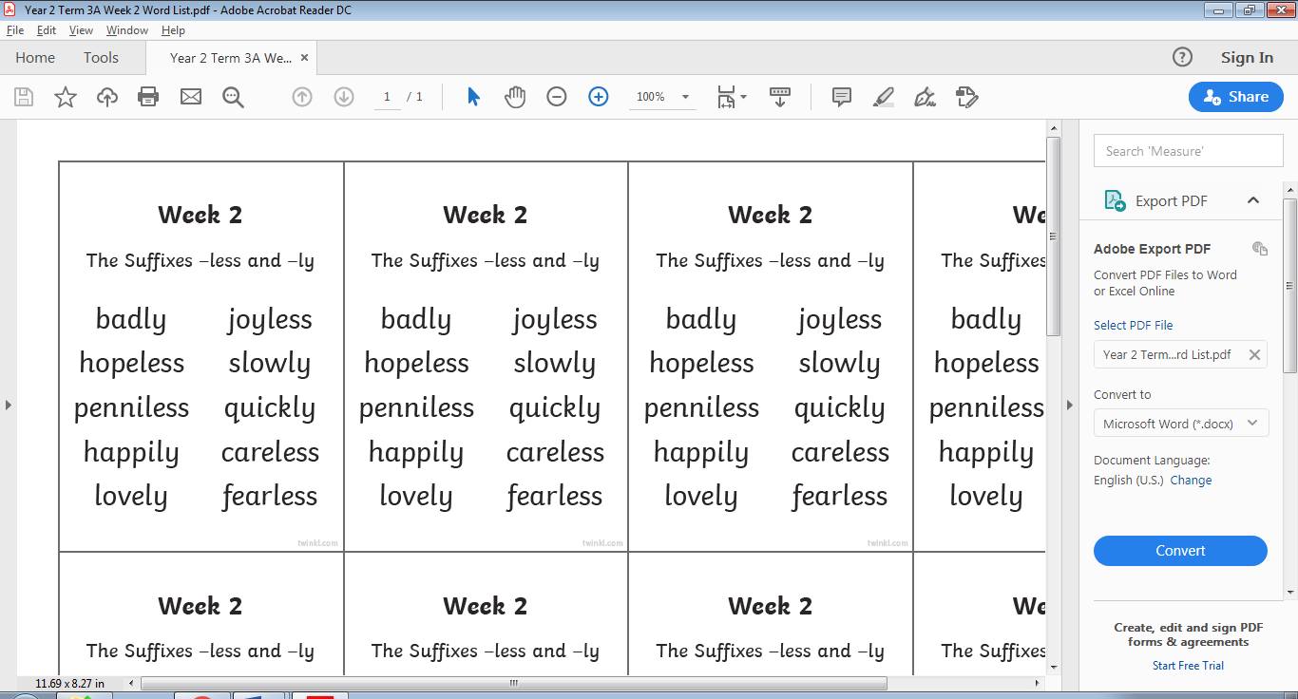
This week’s spellings are:

Please find an attached spelling activity for this week’s spellings in
home learning week 5.

English
Today’s task is to design a horrible and disgusting sandwich to chase the pesky seagulls away from the delicious lunch you prepared yesterday. The more revolting, the better. I have enclosed a worksheet to mind map the ingredients. It does not have to be food as the ingredients, it could be insects or bugs, parts of a body, something that birds won’t like (remember birds love worms so don’t include them in your sandwich!) Once completed write an explanation why you choose the ingredients and what you think the birds will say to each other. Remember to include “inverted comma’s’ in your sentences (also known as speech marks and remember our little hack 66 to open the speech and 99 to close the speech.)

Maths
Today’s objective in maths is to be able to count money in coins. To begin with, challenges include questions to support using up to 5 of the same type. And working with values up to 50p. Then to extend your learning on page 2, there are questions to support using up to 10 coins of up to 2 different types and working with values up to 99p.
Extension- If you fancy a challenge, why not have a go at page 3. These challenges include questions using up to 10 coins of varying types.

PSHE
Please continue with you daily kindness calendar activity. Please remember that these daily acts of kindness can be recorded in your home learning exercise books.

Computing
We have set you a few activities on Purple Mash, linked to Science.
Can you label the different parts of a plant, and label the parts of a plant and the things that help it grow? Then we would like you to design your own garden using the 2 paint activity.

