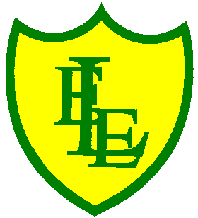
ECCLESTON LANE ENDS
SCHOOL CLOSURE WORK

YEAR: 2
DATE: Monday 4th May 2020
Please note, any work set for home learning does not need to be printed out. If you can print things out, then that’s great but we are aware of different home circumstances and not everyone having the means to do so. Therefore, we sent home a blank exercise book so that work completed at home could recorded in there. Alternatively, you record work by any other means possible or have a verbal discussion to complete certain tasks- be as creative as you like! We understand that during these unprecedented and difficult times, your main priority is the health and wellbeing of your families, as is ours. Any tasks set are meant to aid the home learning process by being as fun and engaging as possible without being too onerous.
PE: 9-9.30am
Log in to YouTube at 9am to access a 30-minute PE lesson with Joe Wicks, the body coach. https://www.youtube.com/user/thebodycoach1 Also, take a look at the keeping active and mindful website Fitter Future, for some different activities to stay active during this time.

Reading
Remember in Year 2 we should be reading at home as much as possible but preferably for 15-20 minutes every day. This should be a book that you read for pleasure.
Today we would also like you to read the information text ‘All about Lighthouses’ and answer the questions about what you have read, in your home learning exercise books.

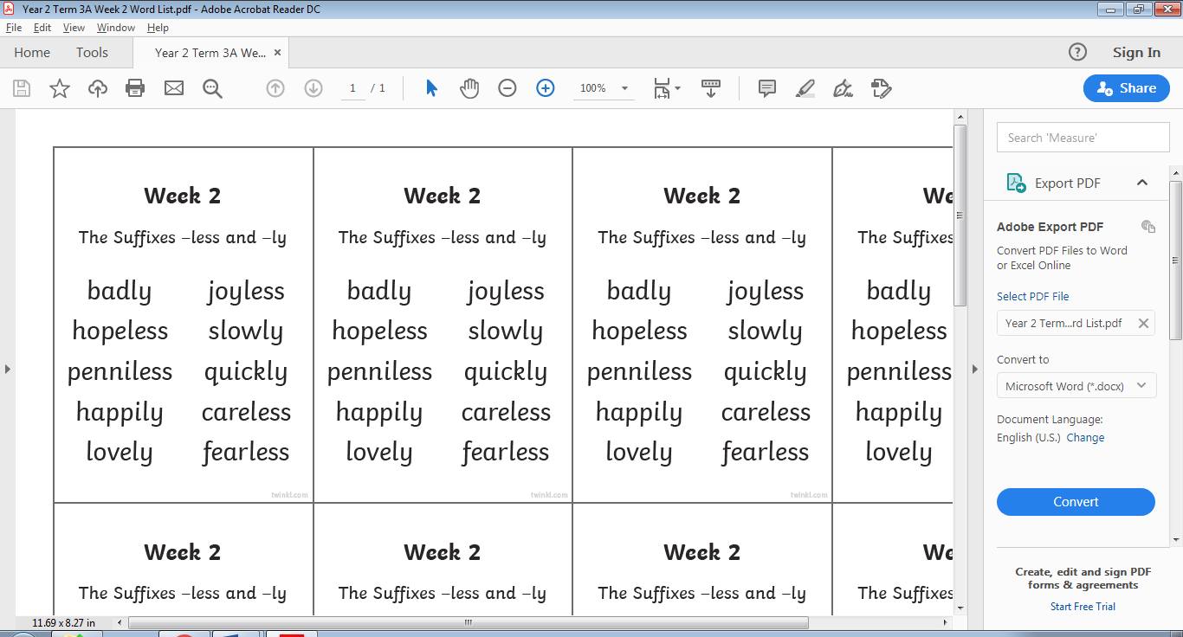
Spellings
This week’s spellings are:

Please find an attached spelling activity for this week’s spellings in our home learning week 5 folder on our class page.

English
In today’s English lesson, I would like you to pretend you are Mrs Grinling and are preparing a delicious, scrumptious lunch for your husband who is going out to work in the lighthouse. You need to design a healthy lunch that is well balance. What would you make for him? What type of food would you put it in? Design this lunch using either you home learning book or on the computer using images. You have to write what you have prepared and draw pictures of the items and label.
If it was Mrs Clarke making Mr Clarke’s lunch, I would make him a tasty ham barm cake with tomato, cucumber and spinach. A slice of cheese and broccoli quiche. A small, pork pie (All Wiganers love a pie!) He loves to drink traditional lemonade so I would include a small bottle. Some slices of watermelon and juicy, green grapes.
Now I wouldn’t include any fish in his lunch as he doesn’t like the taste of fish at all.
For pudding he would love a large piece of tiramisu with some pouring cream to go on top.
Below is a reminder of what Mrs Grinling made her husband.

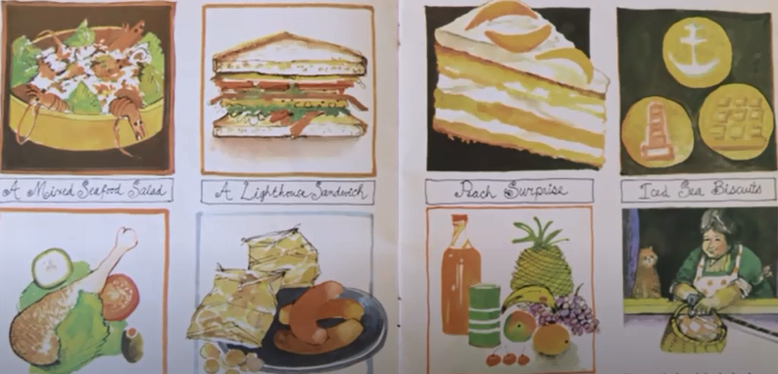
https://www.youtube.com/watch?v=46wCRq50Wwg
All of your items that you have been saving and gathering for English/DT will be needed for Thursday 7th May.

Maths
This week in maths we will be learning all about money. Today your task is to recognise the different British coins and notes. If possible at home ask your parents if you can look and handle some coins and notes so that you can familiarise yourself with the different denominations. Think about what you already know about these items. Think about how some coins have special colours and some have special shapes. With the notes, discuss their colour and design, focusing on the number, symbols and the amount of money written in words. For today’s activities, follow the BBC Bitesize link below for the lesson on ‘recognising coins’. The link consists of a video and interactive activities to complete on line.
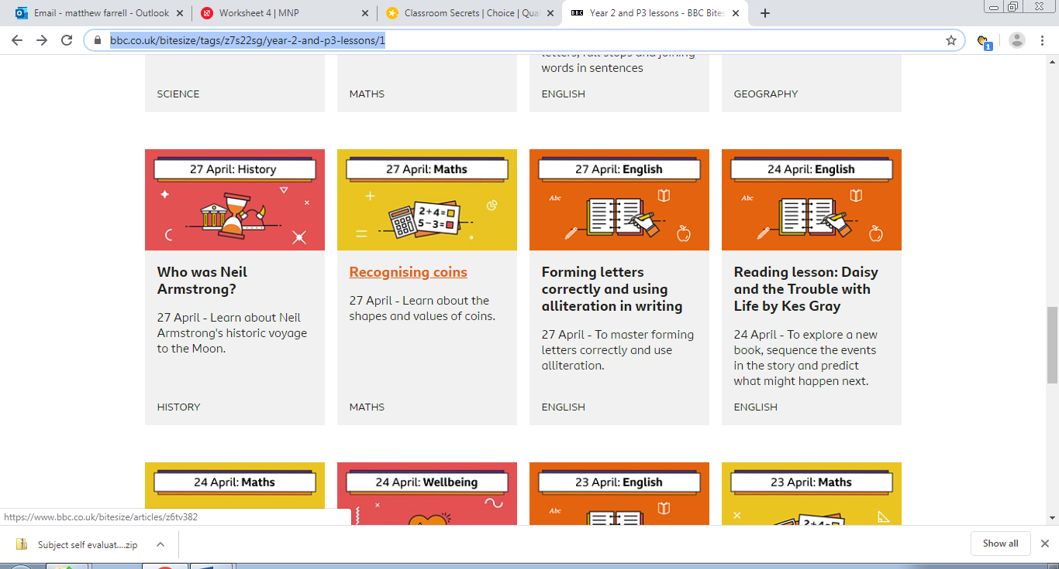https://www.bbc.co.uk/bitesize/articles/z6tv382
Extension- If you fancy a challenge, why not draw the coins / notes out and match them up with the correct sign whether it be pence (p) or pounds (£).
Science
Continuing with our Science work, learning about plants, please use the following link to watch the BBC Bitesize clips, ‘what is the lifecycle of a plant?’ and find out how a dandelion’s seeds are spread by the wind. https://www.bbc.co.uk/bitesize/topics/zpxnyrd/articles/z2vdjxs
Then take the short quiz to see what you have remembered.

