Wednesday 29th April 2020
Character descriptions

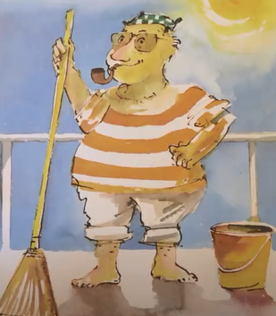

Mr Grinling is …

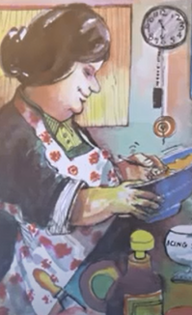

Mrs Grinling is …

Fred Tom Bert

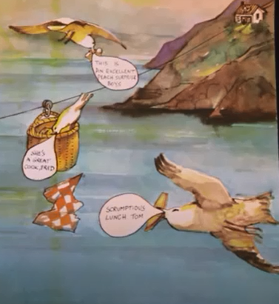

Who is the other character in the story?
Draw a picture in the box writing some adjectives around this character before writing some descriptive sentences.
Meoooooow! (that’s a clue!)

