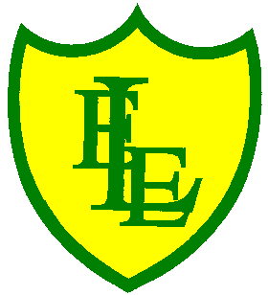
ECCLESTON LANE ENDS
SCHOOL CLOSURE WORK

YEAR: 2
DATE: Tuesday 28th April 2020

PE: 9-9.30am
Log in to YouTube at 9am to access a 30-minute PE lesson with Joe Wicks, the body coach. https://www.youtube.com/user/thebodycoach1 Also, take a look at the keeping active and mindful website Fitter Future, for some different activities to stay active during this time.

Reading
Remember in Year 2 we should be reading at home as much as possible but preferably for 15-20 minutes every day. This should be a book that you read for pleasure.
Please read chapter 2 of ‘A Village Full of Vegetables’ then complete the short quiz and activities about what you have read.
https://www.purplemash.com/

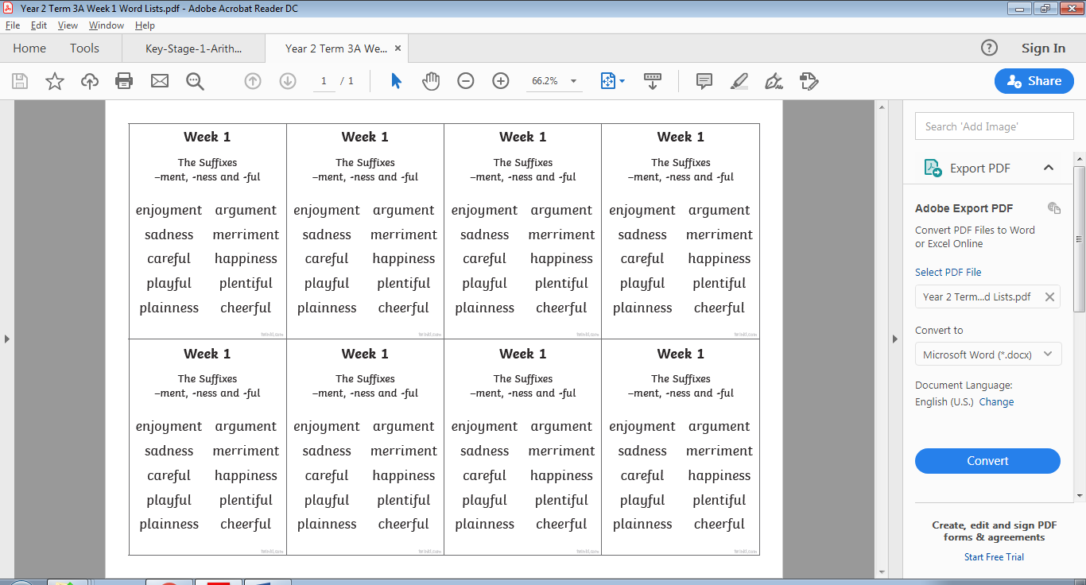
Spellings
This week’s spellings are:

Please find an attached spelling activity for this week’s spellings in
home learning week 4.

English
We hope you enjoyed the story of the ‘The lighthouse Keeper’s Lunch’ yesterday. Some of the words you found in the dictionary yesterday will help you with today’s work and understanding of the sentences. Today’s task will be to complete a reading comprehension based around the book. Remember when answering the questions, some may require you to write in full sentences. You may need to use commas in a list. You will also have to give your own ideas and explanation. I have enclosed the link for the book again which you can pause to complete the sentences or check you’re your answers. Punctuation is key! We do not need to remind you all of the basic punctuation and I am sure you are challenging yourself.
https://www.youtube.com/watch?v=46wCRq50Wwg
Maths
Today we will be focusing on finding a quarter of a number.
Like with finding a third, for our daily maths activity, some questions have pictorial representations but for those that do not here is a little tip to help you along the way.

My top time for finding a fraction of a number or an amount is this:
For example if you were asked to find 1/4 of 20.
Firstly look at the denominator. If the denominator is 4 then draw out 4 baskets (circles). Then share the quantity or number (in this case 20) into the 4 baskets equally.
Finally like at the numerator. If the numerator is 1, look at the amount in 1 basket and that is the answer.

Remember maths can be physical and you can use objects around the house to help you.
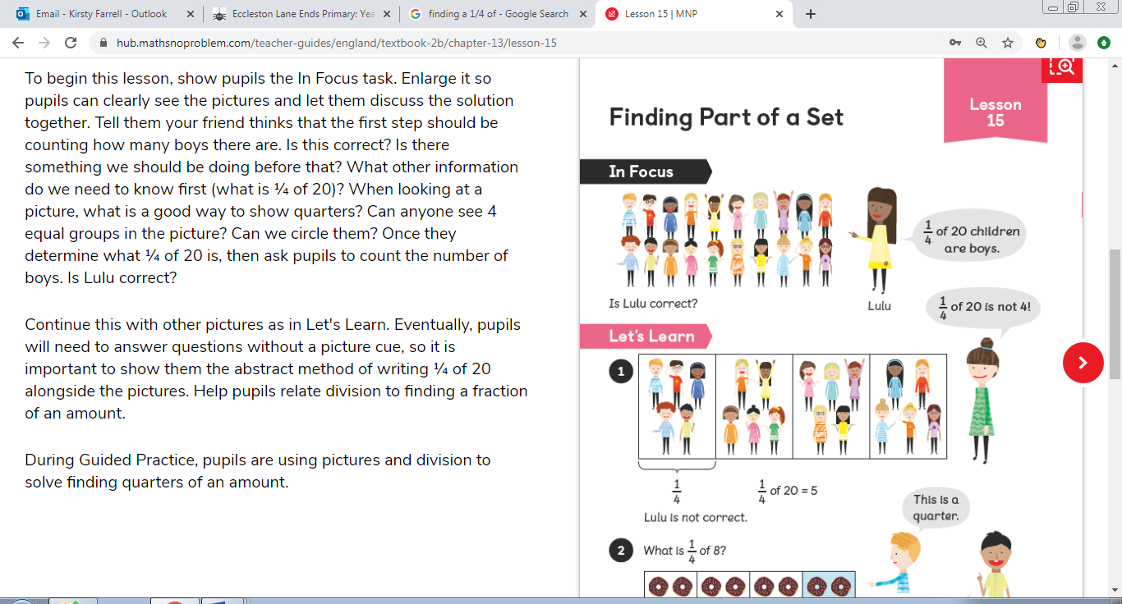

Challenge - A separate fraction challenge has been added to today’s class folder.

Parents – Answers are on the 2nd page.

PSHE
As this Friday is the 1st May and so is the start of a new month, we are setting you a small daily PSHE task for the whole of May. This task is to do something kind each day. Then record your act of kindness by filling in your own ‘Kindness calendar’ (see below & on Year 2 class page). Some examples of acts of kindness are: helping to tidy up, sharing a book with your brother or sister, giving someone in your house a hug or making card for a family members or friends who do not live you, to show them that you’re thinking about them.




