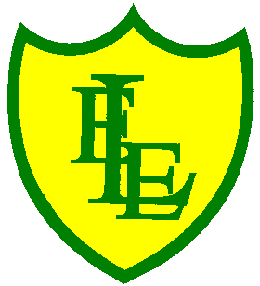
ECCLESTON LANE ENDS
SCHOOL CLOSURE WORK
YEAR: 2
DATE: Friday 24th April 2020
PE: 9-9.30am
Log in to YouTube at 9am to access a 30-minute PE lesson with Joe Wicks, the body coach. https://www.youtube.com/user/thebodycoach1
Also, take a look at the keeping active and mindful website Fitter Future, for some different activities to stay active during this time.

Reading
Please read the final chapter of ‘Daisy’s Memory Box’ and complete the activities about what you have read in chapter 5.

Spellings
For the ‘Mega Spring Spelling Quiz’, I have uploaded a video for you to test your spring spelling knowledge. Pencil and paper at the ready and GOOD LUCK!!

I have also uploaded some handwriting practise which includes all the spelling sentences from this week’s quiz.
Why not record on our spelling blog what you scored!!!

English Whole KS1 task (Y1/Y2)


Today’s English task is a little bit of a different task, it’s all about a gentleman who has recently been in the news for lots of positive reasons. He is called Captain Tom Moore (99) who recently completely 100 laps of his garden to raise money for the National Health Service Charities. Captain Moore, a soldier during World War II, wanted to raise £1000 for the charities however; he has currently help to raise over £26 million (as we type this). This is a huge amount of money and we think this needs to be honoured.
Captain Tom will be 100 years old on the 30th April 2020.
Your task for today in English is to choose between designing and making Captain Tom a birthday card.
You can send the card to Captain Tom or if you are unable to do this put it in your window when it is his birthday.
Or the other task is to design a poster to Captain Tom expressing thanks for his tremendous effort. Explain how his effort made you feel. Make your designs colourful and fun.
Like so many on lockdown Captain Tom can’t spend his birthday with his family or friends but if he received a birthday card or poster, imagine how happy this would make him feel.

The address to send his card or poster is
Captain Tom Moore
C/O Post Office Limited,
67 Bedford Road,
Marston
Moretaine,
Bedfordshire,
England
MK43 0LA,

https://www.youtube.com/watch?v=Tm7QiCOvz3o
You can see Captain Tom cross the finish line. Huge congratulations Captain Tom.

Maths
Today I have included an arithmetic quiz so that we are regularly practising our arithmetic skills and the 4 number operations + - x ÷ . Remember the methods you prefer to use when tackling a question and remember to show your working out.
Extension- If you fancy a challenge, why not have a go at these:
https://www.bbc.co.uk/bitesize/articles/zn9fy9q
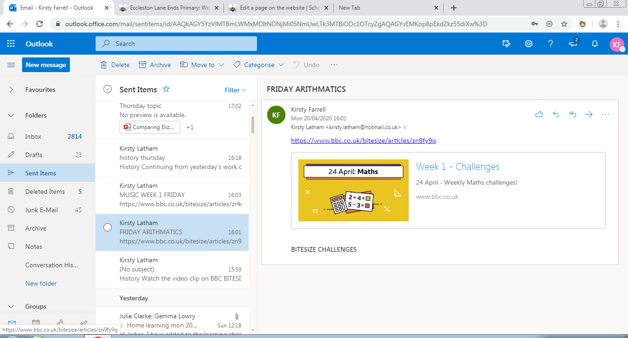
Spanish
Hello children, I hope you had a lovely Easter break and the Easter bunny left you some delicious treats! Here is a Spanish video for you to watch - Saludos (greetings) - Irene en Casa. It is all about greetings in Spanish. Listen along with Irene, play the games and practise your speaking and listening with her! I hope you enjoy this,
Mrs Orledge
https://youtu.be/iDbQzYgXkaE

Music
Why not practise your singing skills and learn how to use your voice expressively and creatively? Click on the link below and join in with the music lesson.
https://www.bbc.co.uk/bitesize/articles/zr4nscw

