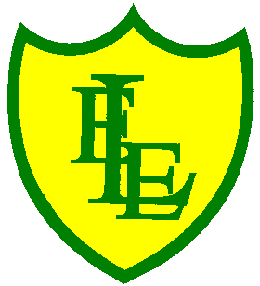
ECCLESTON LANE ENDS
SCHOOL CLOSURE WORK

YEAR: 2
DATE: Thursday 23rd April 2020

PE: 9-9.30am
Log in to YouTube at 9am to access a 30-minute PE lesson with Joe Wicks, the body coach. https://www.youtube.com/user/thebodycoach1

Reading
Please continue with the reading activity on Purple Mash. Today is chapter 4 of ‘Daisy’s Memory Box’. I hope you are enjoying activities about what you have read.
https://www.purplemash.com/

Spellings
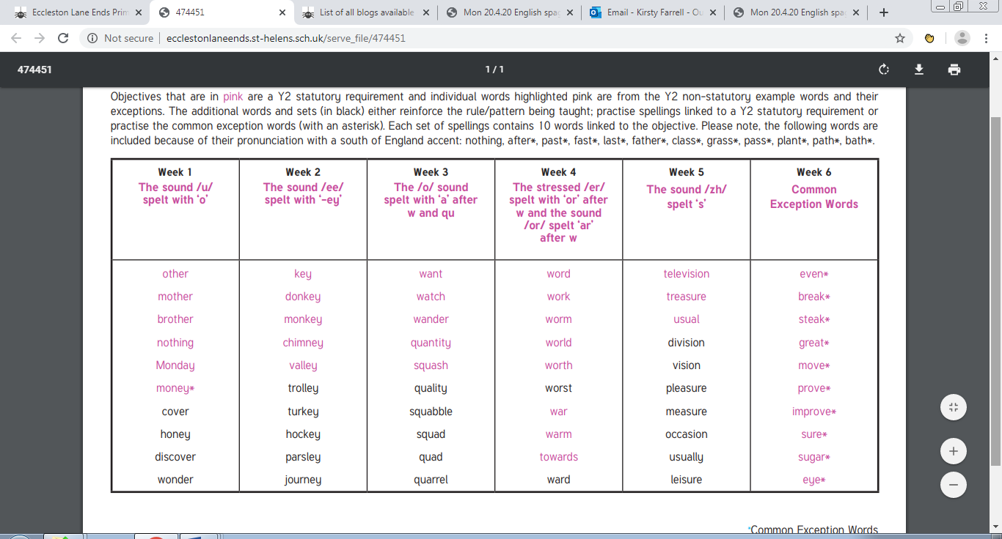
In preparation for the ‘Mega Spring Spelling Quiz’ at the end of the week, why not focus on weeks 5 and 6 today. Use the spell well activities found in our ‘spell well’ folder on our class page.

English
Today in English, we will conclude our SPaG activities. We hope you have found them useful and a tool to recap on our prior learning. Today’s task is all about ‘Apostrophes for Possession’. I have enclosed a scaled down power point to recap what an apostrophe is and information and activities to do regarding apostrophes. I have also included a worksheet activity pack and I would suggest, with help and support from parents, please complete pages 4 and 5. The answers are also there for guidance. If you want to find more activities to do at home and challenge yourselves, there are some excellent websites that will aid your learning. Below are a few examples.

BBC bitesize is very good and have just launched a 14 week home learning programme covering lots of different subjects.
Twinkl are allowing parent access, which is free to download some of the resources.
Top marks is another great one for interactive games.

Maths
In maths today, we will be looking at finding ½ of a number. In today’s challenge, there are questions to support finding a half by dividing the whole number or quantity into two equal parts, grouped pictorial support and scaffolding is provided to begin with.
Remember your doubles and halves as they will help you!

I have attached a useful Link – Watch the video clip on
‘What are fractions?’ Then why not take the quiz at the end of the lesson.
https://www.bbc.co.uk/bitesize/topics/z3rbg82/articles/zq2yfrd

History - continued
Continuing from yesterday’s work on Queen Victoria, today we are going to compare her as a queen with the earlier Queen Elizabeth I. See attached worksheet. Complete the column about Queen Victoria with the knowledge gained from yesterday. Then watch the BBC BITESIZE clip on Queen Elizabeth I. https://www.bbc.co.uk/bitesize/topics/zkrkscw/articles/zkh7bdm
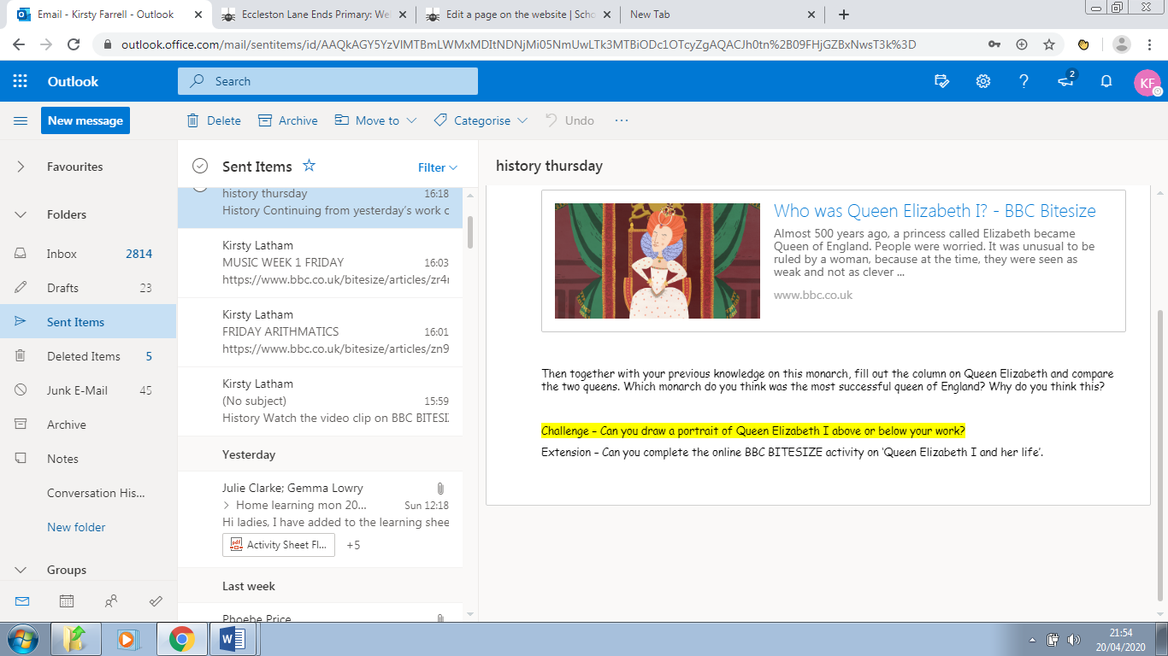

Then together with your previous knowledge on this monarch, fill out the column on Queen Elizabeth and compare the two queens. Which monarch do you think was the most successful queen of England? Why do you think this?

Challenge – Can you draw a portrait of Queen Elizabeth I above or below your work?

Extension – Can you complete the online BBC BITESIZE activity on ‘Queen Elizabeth I and her life’.

