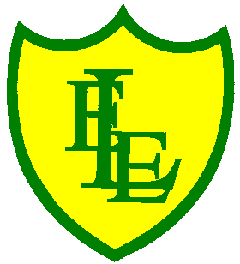
ECCLESTON LANE ENDS
SCHOOL CLOSURE WORK

YEAR: 2
DATE: Wednesday 22nd April 2020

PE: 9-9.30am
Log in to YouTube at 9am to access a 30-minute PE lesson with Joe Wicks, the body coach. https://www.youtube.com/user/thebodycoach1

Reading
Please continue with your reading activity on Purple Mash. Please read chapter 3 of ‘Daisy’s Memory Box’ and then complete the short quiz and activities about what you have read.
https://www.purplemash.com/

Spellings
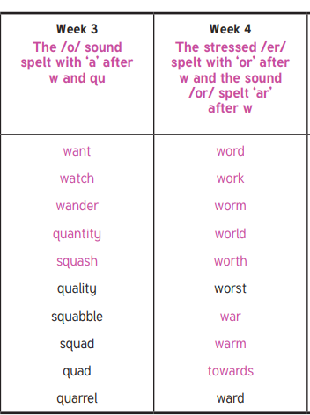
In preparation for the ‘Mega Spring Spelling Quiz’ at the end of the week, why not focus on weeks 3 and 4 today. Use the spell well activities found in our ‘spell well’ folder on our class page.

English
Today’s task is to go back over your answers and self-mark and correct them. You can do this with a crayon, coloured pencil, highlighter or felt tip pens (just like in our Y2 classroom). Remember it is ok if you have got answers incorrect, mistakes mean we can correct them and learn from theses moving forward in our learning. Parents’ go through each answer with your child asking them to give you their answer first. If they have got it correct great, give it a √ if it is incorrect add a C to the correction, we never add a X. Explain the correct answer and why making sure that your child knows the reasons. The answers are all on yesterday’s sheet.
Once you have finished, visit BBC bitesize and complete this fun, interactive SPaG game.

https://www.bbc.co.uk/bitesize/subjects/zgkw2hv
Click on small town superheroes- double click to play and select punctuation (the house pic) listen to the short introduction and then select all punctuation. Read though and think clearly where the correct punctuation should go in the text.
Maths
As a follow on from counting in fractions before Easter, today in maths we are going compare and order fractions with the same denominator (same bottom number). To begin with the children will have access to pictorial fractions to help them visualise their sizes. For example:
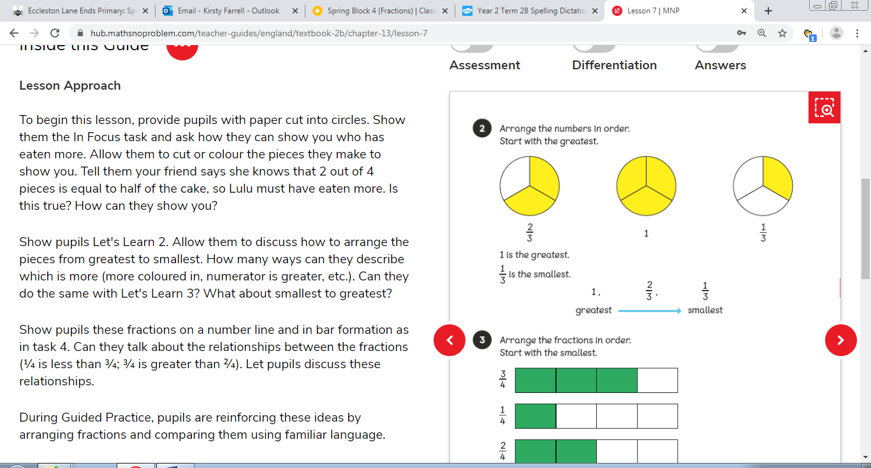
1 whole is 3/3 so therefore the greatest, then 2/3 and 1/3 is the smallest (only one fraction coloured in).

Some questions will just give the fraction in numbers.

*If needed, your child could draw out their own circles and colour in the different fraction amounts to visualise the fractions. Make sure each circle is the same size and is split up into the denominator number (3 is the example).

Challenge - The second worksheet wants you to compare fractions with a different denominator number. The same rule applies in that you colour in the numerator (top number of the fraction) on each shape given. However, if you need to draw your own shapes to visualise the fraction, make sure each of the shapes are the same size but if they have a different denominator split them by that number. Finally, use the numerator (top number of the fraction) and colour the fraction pieces in according to this number.

Example - These circles are all the same size but split into different amount because of their denomiator number. All 3 circles have only 1 fraction coloured in though because all three fractions have the numerator of 1.

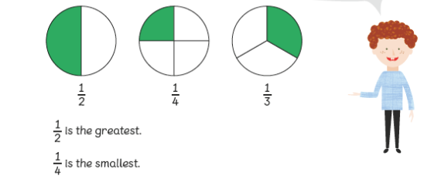

Useful Link – Watch the video clip on ‘How to write fractions’
Then why not take the quiz at the end of the lesson.
https://www.bbc.co.uk/bitesize/topics/z3rbg82/articles/zt7nfrd

History
Watch the video clip on BBC BITESIZE on Queen Victoria.
https://www.bbc.co.uk/bitesize/topics/zkrkscw/articles/zfdkhbk
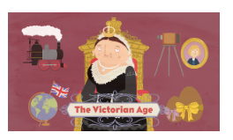
Before you watch the video think about this question –
Why was Queen Victoria a significant and successful queen of England?
After watching the video and from previous knowledge, can you think of and write out 5 reasons why she was a successful monarch.
Queen Victoria was a successful queen of England because…
Complete this activity in your home learning book.

Challenge – Can you draw a portrait of Queen Victoria above or below your work?

Extension – Can you complete the online BBC BITESIZE activity on ‘Queen Victoria and her life’?

“You’ve got to aim high and see where you land.”

