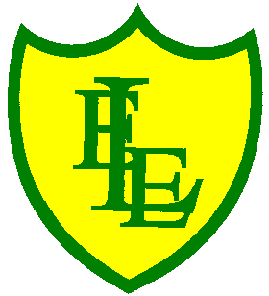
ECCLESTON LANE ENDS
SCHOOL CLOSURE WORK

YEAR: 2
DATE: Tuesday 21st April 2020

PE: 9-9.30am
Log in to YouTube at 9am to access a 30-minute PE lesson with Joe Wicks, the body coach. https://www.youtube.com/user/thebodycoach1

Reading
Remember in Year 2 we should be reading at home as much as possible but preferably for 15-20 minutes every day. This should be a book that you read for pleasure.
This week we have also set you a reading activity on purple mash (see the 2Do section).
Please continue to read the next chapter of ‘Daisy’s Memory Box’. Please read chapter 2 and then complete the short quiz and activities about what you have read.
https://www.purplemash.com/

Spellings
In preparation for the ‘Mega Spring Spelling Quiz’ at the end of the week, why not focus on weeks 1 and 2 today. Use the spell well activities found in our ‘spell well’ folder on our class page.
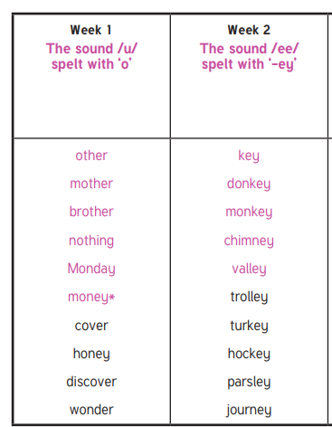

English
Today in English, you will be completing a SPAG treasure hunt quiz. There are 15 questions to complete (Parents, the answers are on next page BUT do not give the answers out until tomorrow please). Cut out the question strips and place them around your home or outside if it’s a nice dry day, the children love finding clues normally in school and it’s a fun way of helping them learn. I have enclosed the instruction sheet for exactly what to do along with the children’s answer sheet. All the SPAG objectives that are on this quiz have already been covered previously in class, so we are just reviewing children’s’ knowledge.

Maths
As a continuation from yesterday’s learning, today I have enclosed a number of revision challenges based on recognising a quarter. Like in class, to consolidate our maths learning we need to be able to demonstrate and explain our thinking and these challenges help you to do so. Challenges include, questions to support recognising a quarter of shapes (including circles, triangles and quadrilaterals). Again, I will leave it up to you how many challenges you want to set yourself to do but I suggest completing at least up to number 5. See if you can challenge yourself further than yesterday!!

PSHE
Today you have a PSHE activity to complete. The activity is based on ‘feelings’ and you will be able to: 1. recognise different feelings in ourselves and others, 2. identify that people can feel differently about things and situations and 3. Explain who can help us with our feelings. Please open the Mental Health PowerPoint that is on our Year 2 class page and read through it. Complete the activities found on the PowerPoint using the feelings vocabulary resource sheet.



