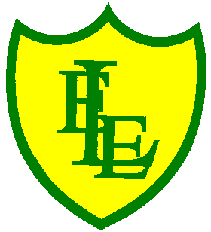
ECCLESTON LANE ENDS
SCHOOL CLOSURE WORK

YEAR: 2
DATE: Monday 20th April 2020

PE: 9-9.30am
Log in to YouTube at 9am to access a 30 minute PE lesson with Joe Wicks, the body coach. https://www.youtube.com/user/thebodycoach1

Reading
Remember in Year 2 we should be reading at home as much as possible but preferably for 15-20 minutes every day. This should be a book that you read for pleasure.
This week we have also set you a reading activity on purple mash (see the 2Do section).
We have allocated you the story ‘Daisy’s Memory Box’. Please read a chapter each day then complete the short quiz and activities about what you have read. Today is Chapter 1.
https://www.purplemash.com/

Spellings

Due to site maintenance over Easter, I was unable to upload the spelling video for week 6 until now. This video is now live if your child wants to access this and test their knowledge!

This week we will be focusing on all of the previous spellings taught last term. The overview has been attached to our ‘spell well‘ section on the website but I have included a snapshot of it on our daily newsletter, so you know what to look out for. I suggest that you split up the spelling revision each day from Monday – Thursday of this week. Then on Friday I upload the ‘Mega Spring Spelling Quiz’ video that will include 20 spellings from weeks 1-6.

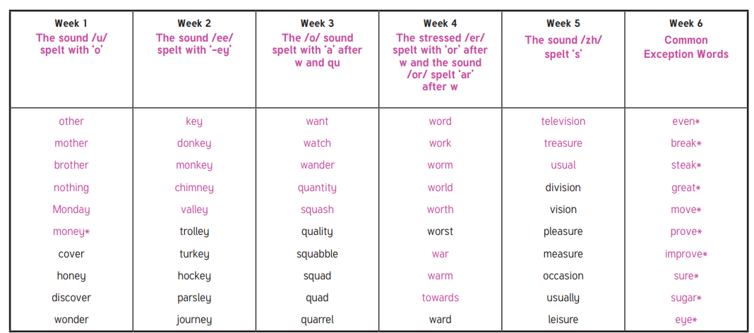

English
This week in English, we will be focusing on spelling, punctuation and grammar. I have enclosed a SPAG mat for you to complete to ease you back into your learning. Try and work independently as we have done many of these in class, if you need a little support, ask your parent(s) to help you. Remember your previous phonics knowledge and spelling rules. We have looked at commas, apostrophes and conjunctions. Before we finished in English we focused on suffixes and have previously looked at the different types of sentences.

Maths
This week in Maths we will be continuing with our fractions learning. Today I have enclosed a number of revision challenges based on recognising a half. Challenges include, questions to support recognising a half, using lengths, groups of objects and shapes when the half is shown using a horizontal or vertical line and using the fraction 1/2. The challenges vary as you go through them. I will leave it up to you how many challenges you want to set yourself to do but I suggest completing up to number 5 if you can.

Science
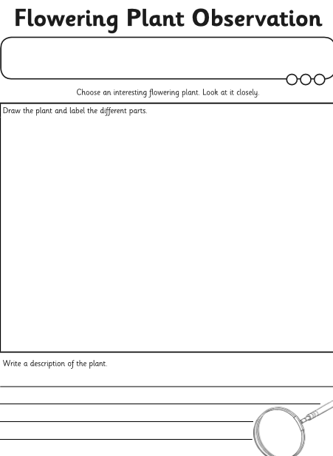
This term in Science we will be learning about plants. Your activity is to look closely at plants and trees and record what you see. Choose an interesting flowering plant to observe this week and complete the following activity sheet, which can be found on our class page.

We hope you all had a wonderful Easter holidays with your family. It wasn’t the Easter we all planned but the weather was lovely, you are all at home happy and safe so we should take lots of positives from this. It’s back to home learning again and challenging yourselves once more.
